DOCKER CHALLENGES
- Create a customized Docker image using a Dockerfile.
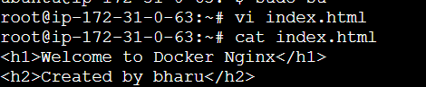
Now lets create a docker file
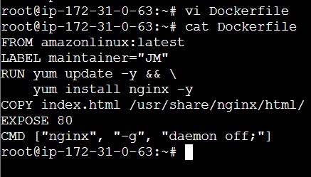
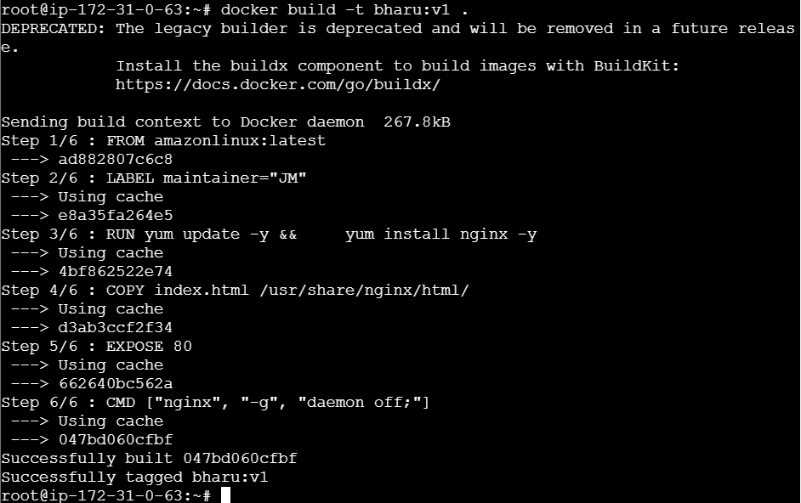
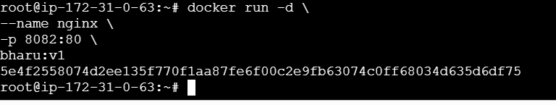
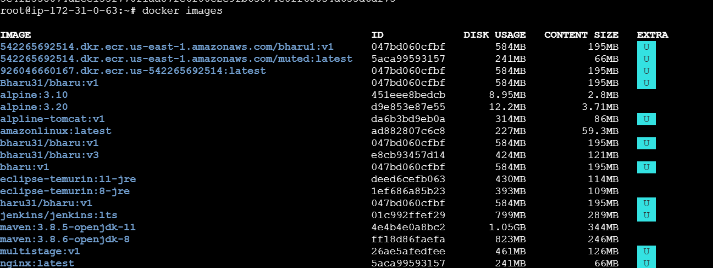
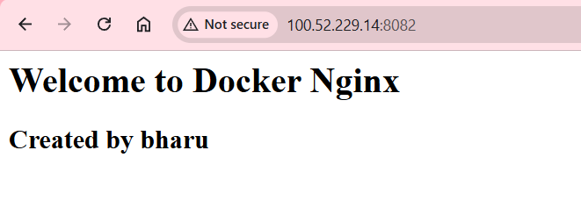
2.Push the image to Docker Hub.
Create a repo in Docker hub
Docker login
docker login ⇒ u will get code need to enter in the browser u will find the link in cli itself and the code too
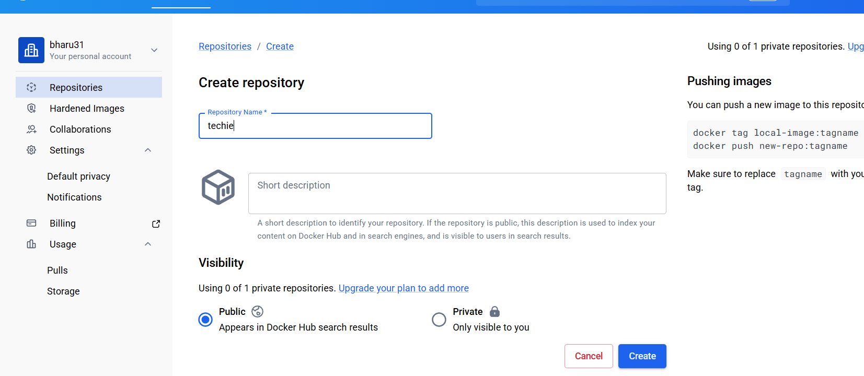
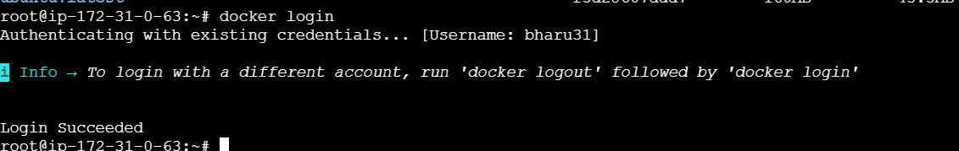

Now lets rename our image name by using command
docker tag bharu:v1 bharu31/techie:v1 and to push the image to repository use the command
docker push bharu31/techie:v1
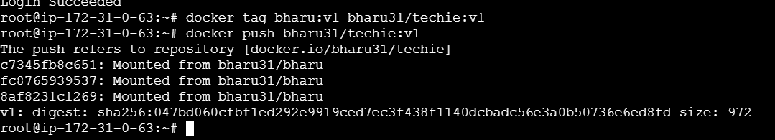
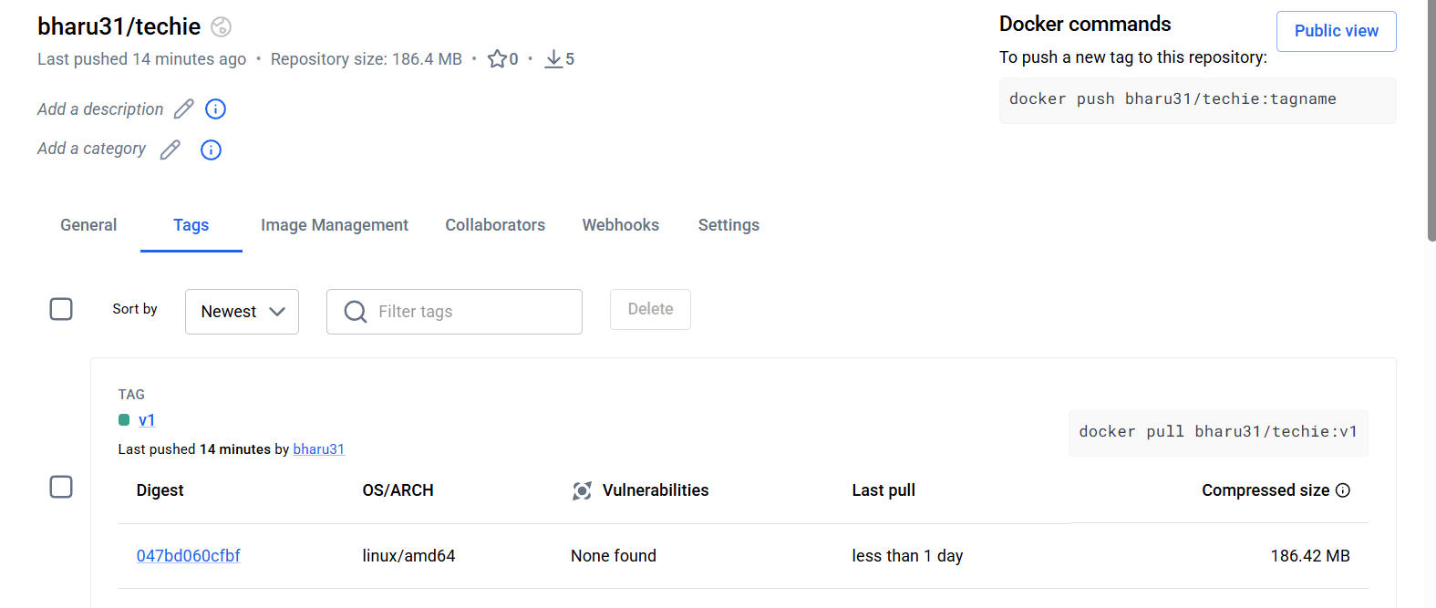
3.Push the same image to Amazon ECR.
Lets create a repo in ECR
sudo apt updatesudo apt install awscli -y aws –version aws configure and Verify Configuration
aws sts get-caller-identity 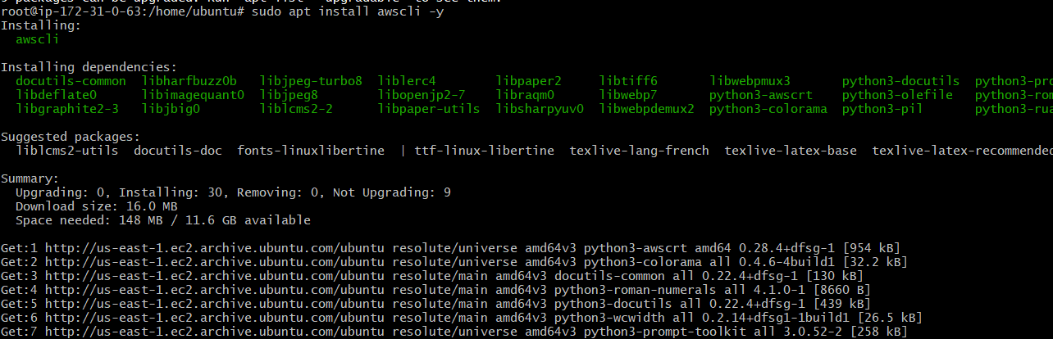
aws ecr get-login-password --region us-east-1 | docker login --username
AWS --password-stdin
- This command goes to create one repository in aws ecr
- 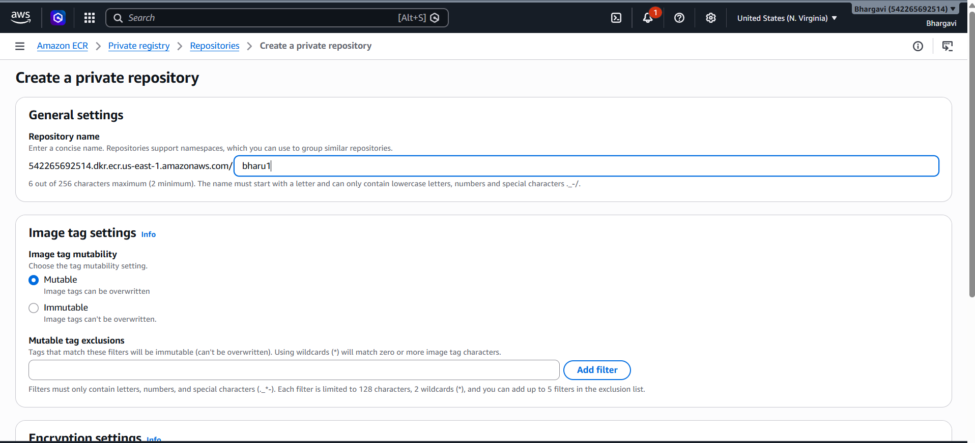
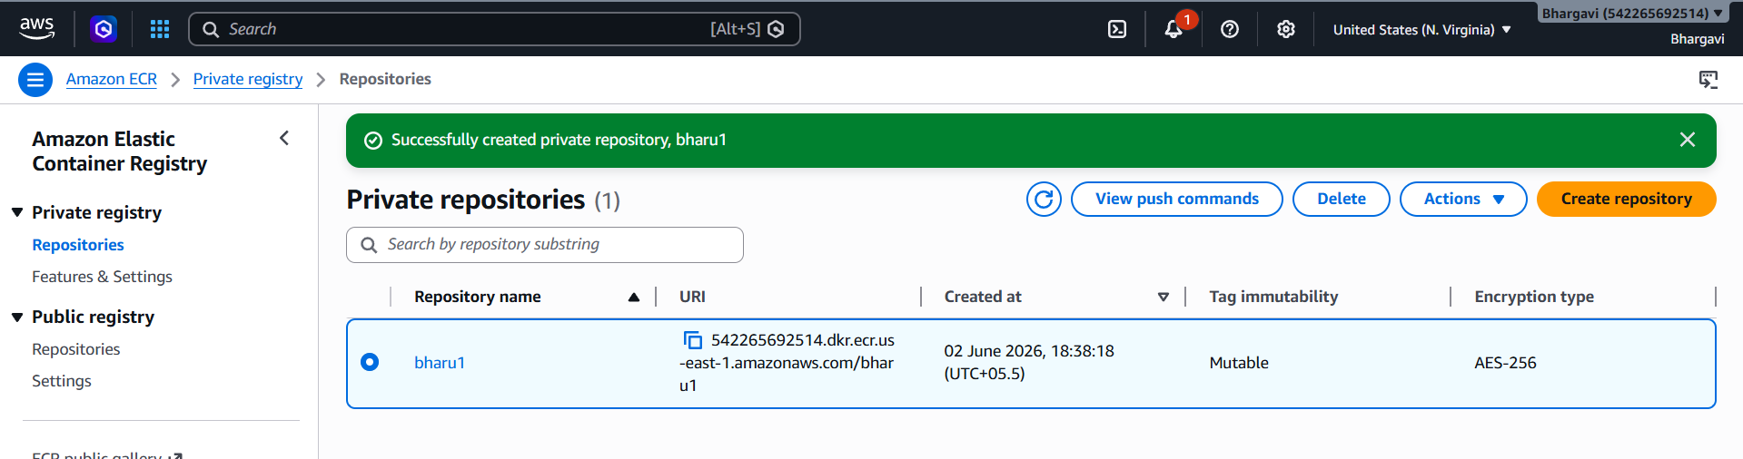
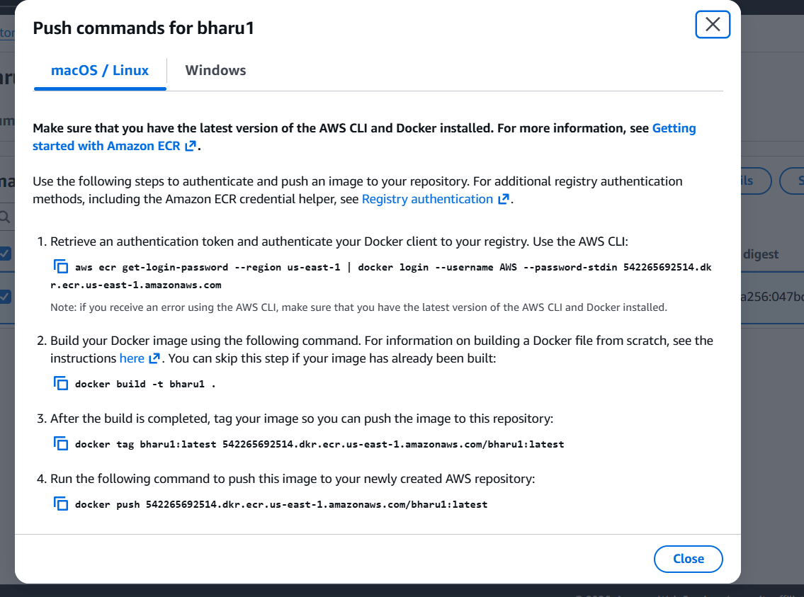

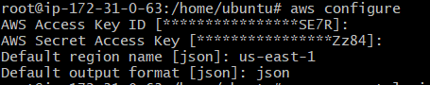
Login using the below command
aws ecr get-login-password --region us-east-1 | docker login --username AWS --password-stdin 542265692514.dkr.ecr.us-east-1.amazonaws.com

url from this
Now lets rename our image to repo name by using command
docker tag bharu:v1 542265692514.dkr.ecr.us-east-1.amazonaws.com/bharu1:v1
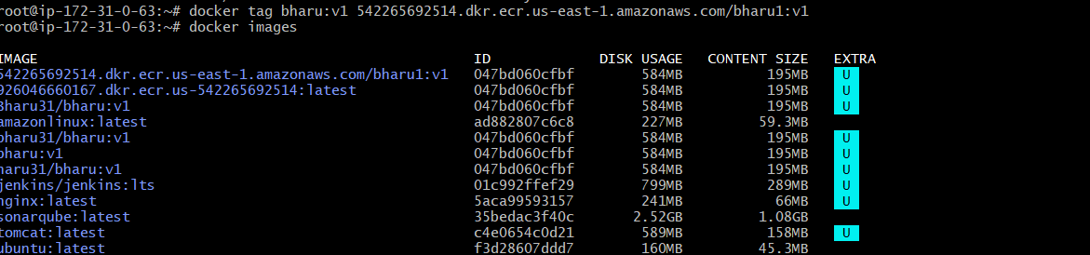
Now lets push to our ECR repo by using command
docker push 542265692514.dkr.ecr.us-east-1.amazonaws.com/bharu1:v1
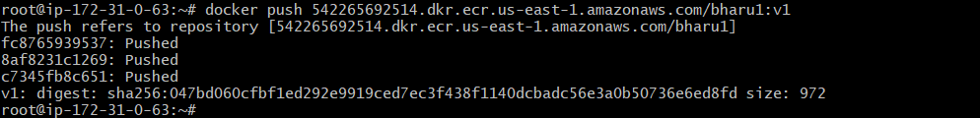
Lets check in the AWS ECR
It has been pushed successfully
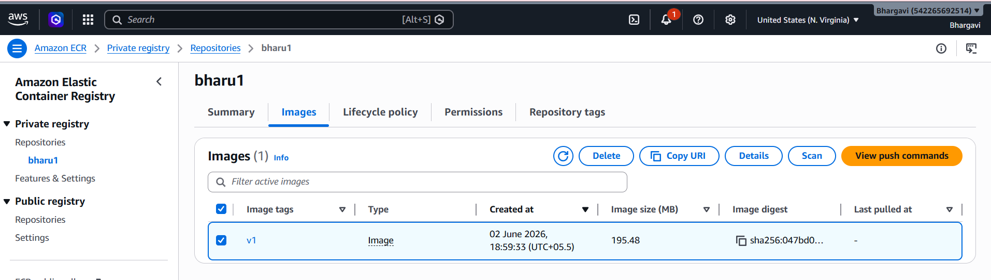

4.Provision one EC2 instance using Terraform and install Jenkins.
- Lets install this command all
wget -O - https://apt.releases.hashicorp.com/gpg | sudo gpg --dearmor -o /usr/share/keyrings/hashicorp-archive-keyring.gpg
echo "deb [arch=$(dpkg --print-architecture) signed-by=/usr/share/keyrings/hashicorp-archive-keyring.gpg] https://apt.releases.hashicorp.com $(grep -oP '(?<=UBUNTU_CODENAME=).*' /etc/os-release || lsb_release -cs) main" | sudo tee /etc/apt/sources.list.d/hashicorp.list
sudo apt update && sudo apt install terraform

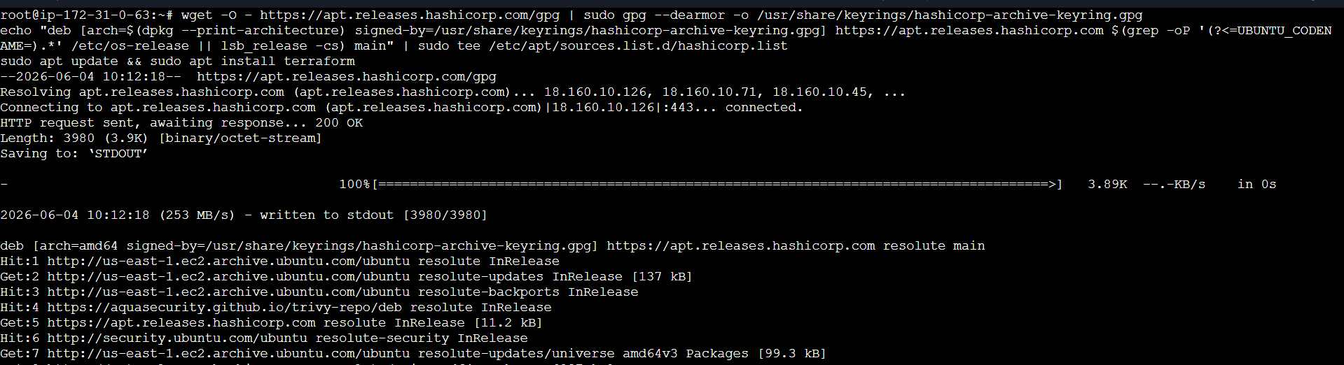
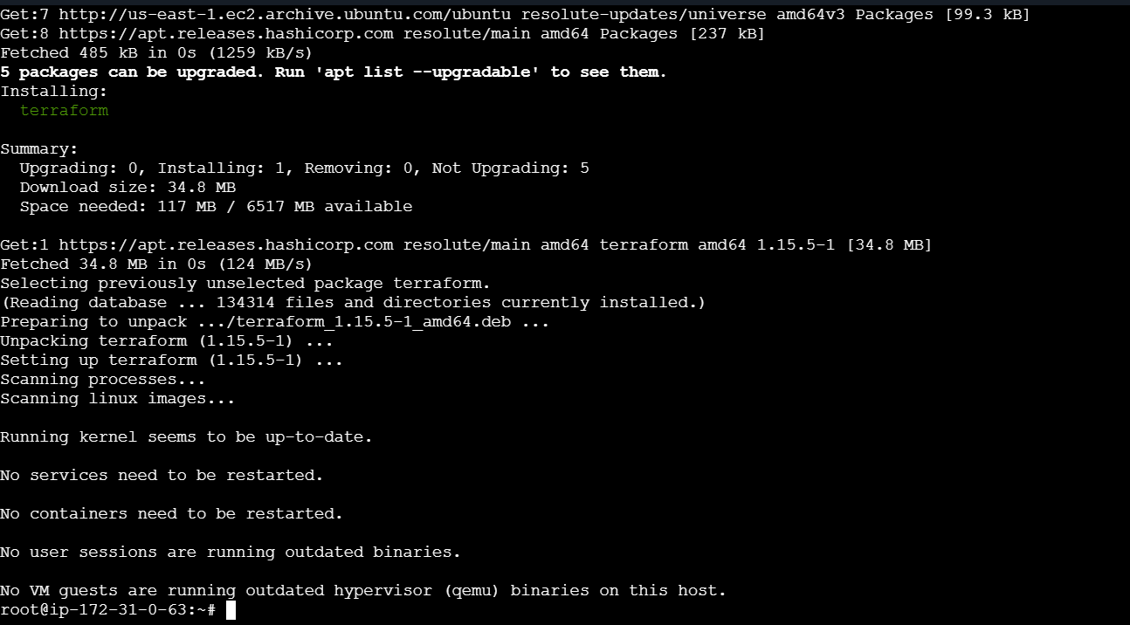
Lets confirm if terraform has been installed or not
terraform –version
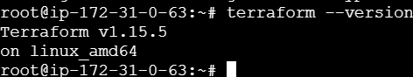
Aws configure
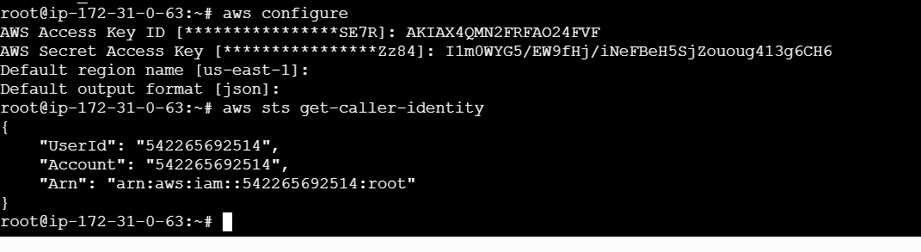
Create a directory and changing to that directory i will be using the command
mkdir terraform-jenkins / cd terraform-jenkins
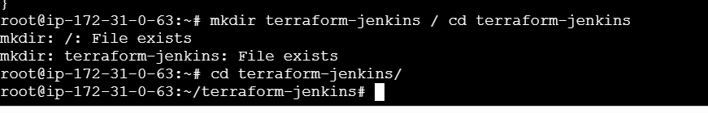
Inside Terraform-jenkins folder lets create some files using
touch main.tf variables.tf terraform.tfvars userdata.sh

Lets add userdata for installing jenkins through terraform in userdata

Why are we using user-data?
AWS runs this script automatically during EC2 launch, so Jenkins gets installed without manual steps.

#!/bin/bash
# Update packages
apt update -y
# Install Java 21
apt install openjdk-21-jdk -y
# Create keyrings directory
mkdir -p /etc/apt/keyrings
# Add Jenkins key
wget -O /etc/apt/keyrings/jenkins-keyring.asc \
https://pkg.jenkins.io/debian-stable/jenkins.io-2026.key
# Add Jenkins repository
echo "deb [signed-by=/etc/apt/keyrings/jenkins-keyring.asc] \
https://pkg.jenkins.io/debian-stable binary/" | sudo tee \
/etc/apt/sources.list.d/jenkins.list > /dev/null
# Update packages again
apt update -y
# Install Jenkins
apt install jenkins -y
# Enable and start Jenkins
systemctl enable jenkins
systemctl start jenkins
leats create vi userdata.sh

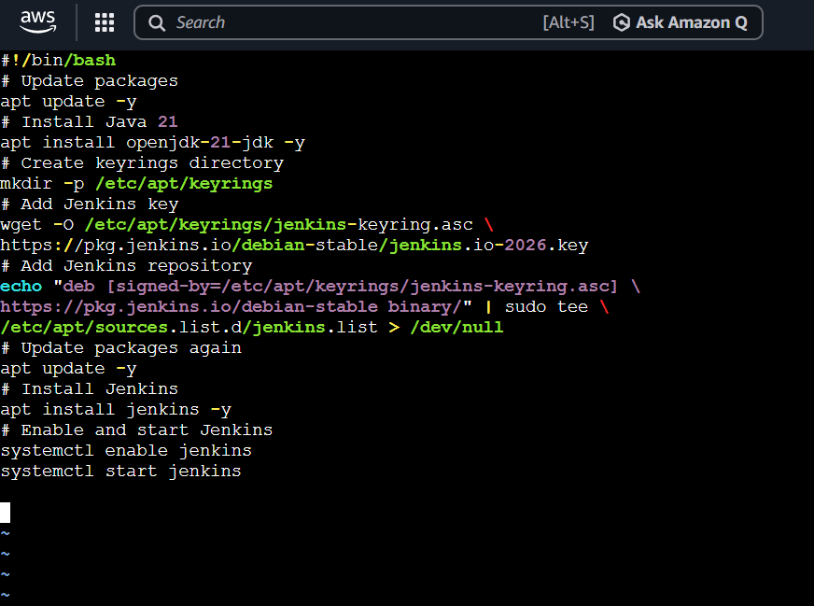
Lets add variables in Create vi variables.tf
variable "aws_region" {
default = "us-east-1"
}

variable "instance_type" {
default = "t3.small"
}

variable "key_name" {
description = "AWS Key Pair Name"
}
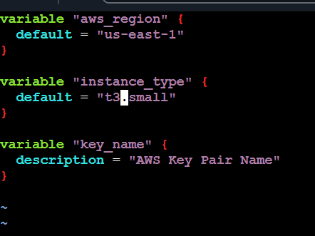
Lets open vi terraform.tfvars

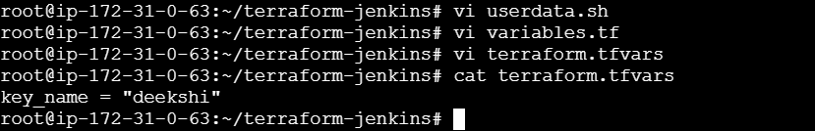
Lets create vi main.tf
provider "aws" {
region = var.aws_region
}

# Get latest Ubuntu AMI
data "aws_ami" "ubuntu" {
most_recent = true

owners = ["099720109477"]

filter {
name = "name"
values = ["ubuntu/images/hvm-ssd-gp3/ubuntu-noble-24.04-amd64-server-*"]
}
}

# Security Group
resource "aws_security_group" "jenkins_sg" {
name = "jenkins-security-group"

ingress {
description = "SSH"
from_port = 22
to_port = 22
protocol = "tcp"
cidr_blocks = ["0.0.0.0/0"]
}

ingress {
description = "Jenkins"
from_port = 8080
to_port = 8080
protocol = "tcp"
cidr_blocks = ["0.0.0.0/0"]
}

ingress {
description = "HTTP"
from_port = 80
to_port = 80
protocol = "tcp"
cidr_blocks = ["0.0.0.0/0"]
}

egress {
from_port = 0
to_port = 0
protocol = "-1"
cidr_blocks = ["0.0.0.0/0"]
}
}

# EC2 Instance
resource "aws_instance" "jenkins_server" {
ami = data.aws_ami.ubuntu.id
instance_type = var.instance_type
key_name = var.key_name
vpc_security_group_ids = [aws_security_group.jenkins_sg.id]

user_data = file("userdata.sh")

tags = {
Name = "Jenkins-Server"
}
}

# Output Public IP
output "public_ip" {
value = aws_instance.jenkins_server.public_ip
}

Lets Intilialize terraform using command
What does it does? Downloads AWS provider and Initializes Terraform project
Terraform init
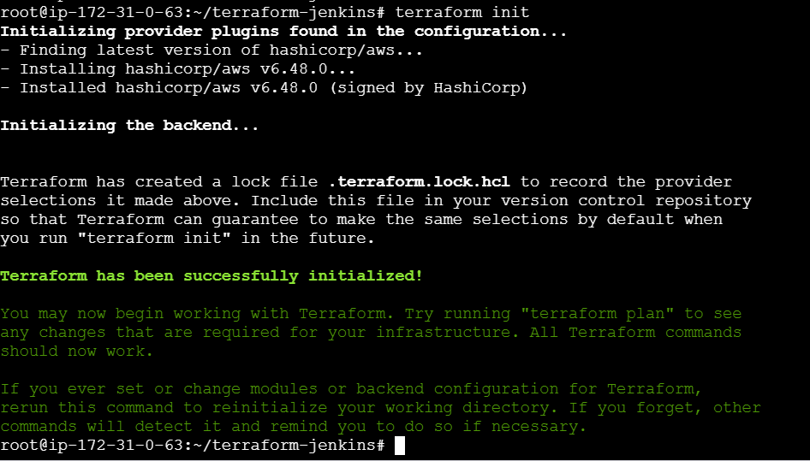
Validating the code using
terraform validate
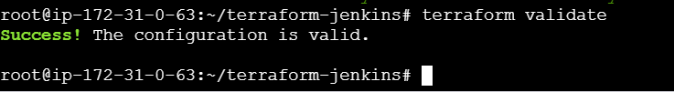
Lets preview the infrastructure using
This shows: EC2 creation and Security group creation
Terraform plan
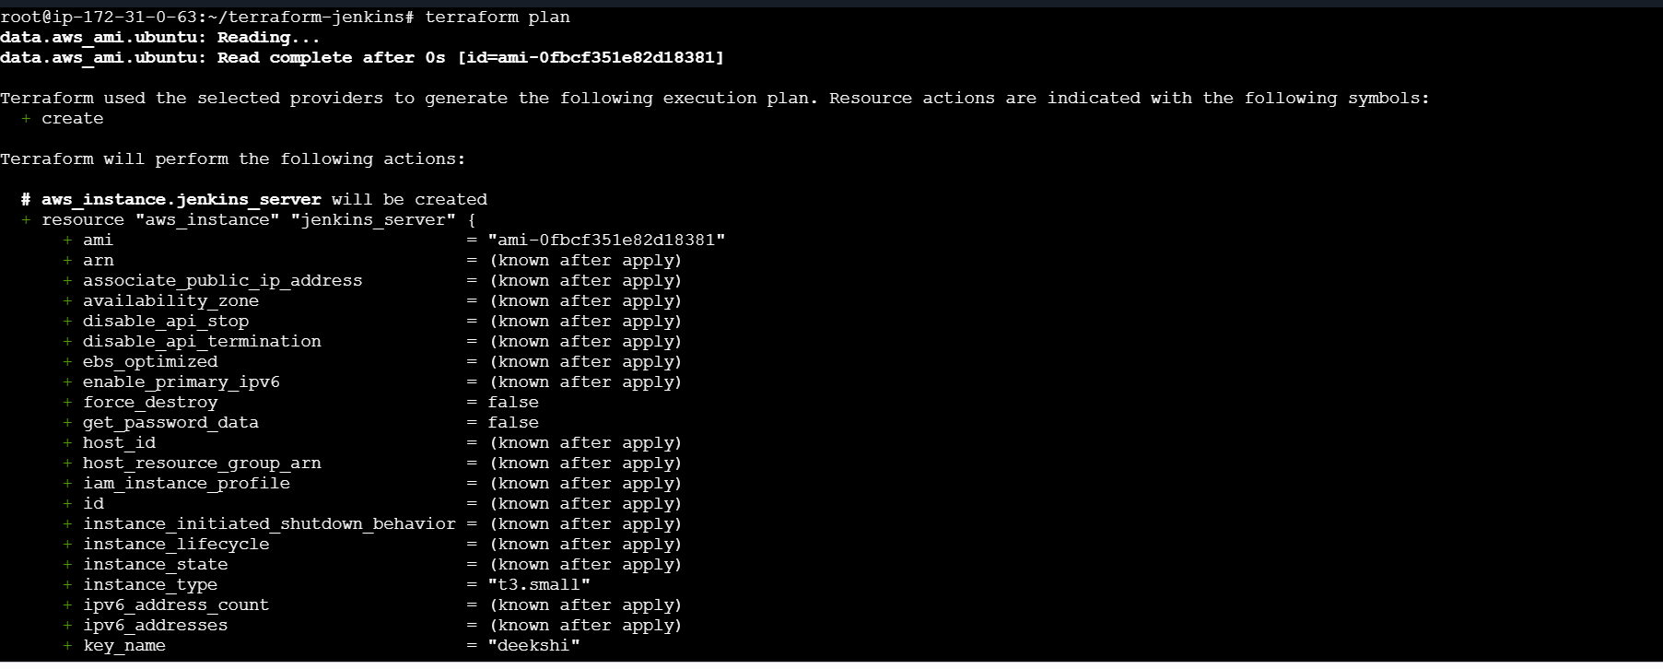
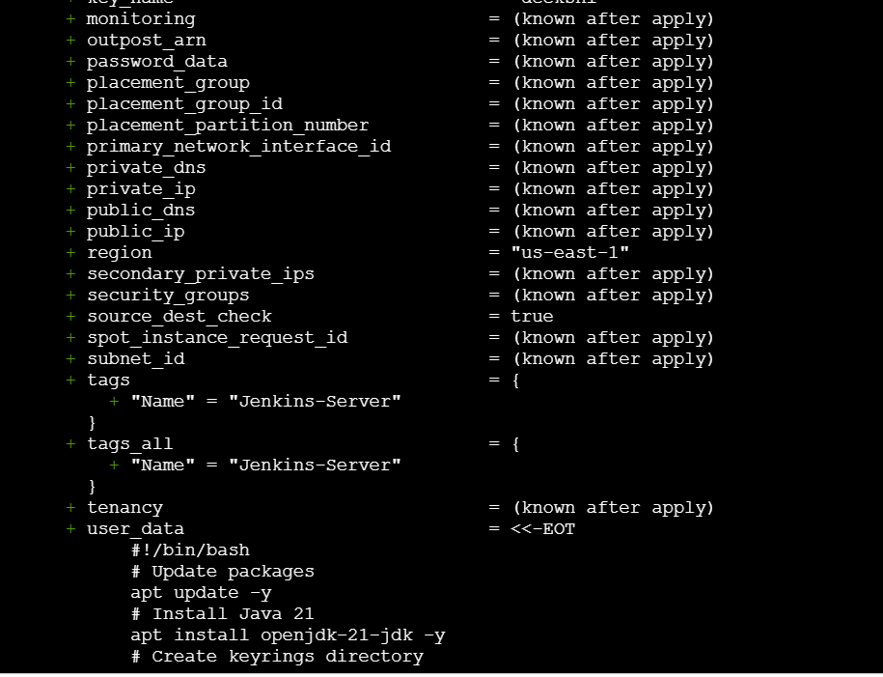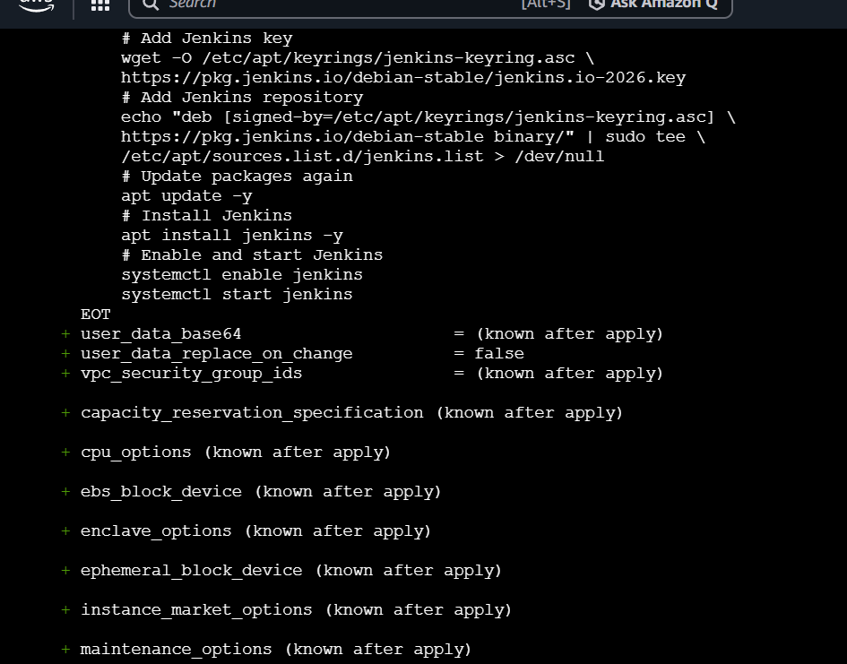
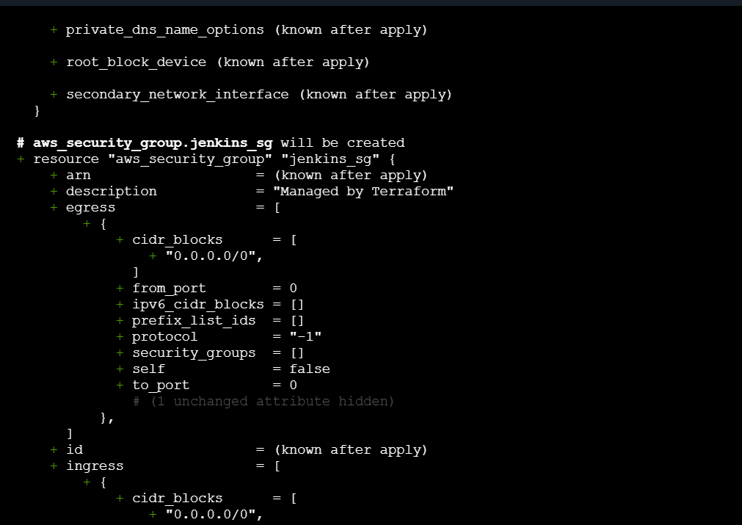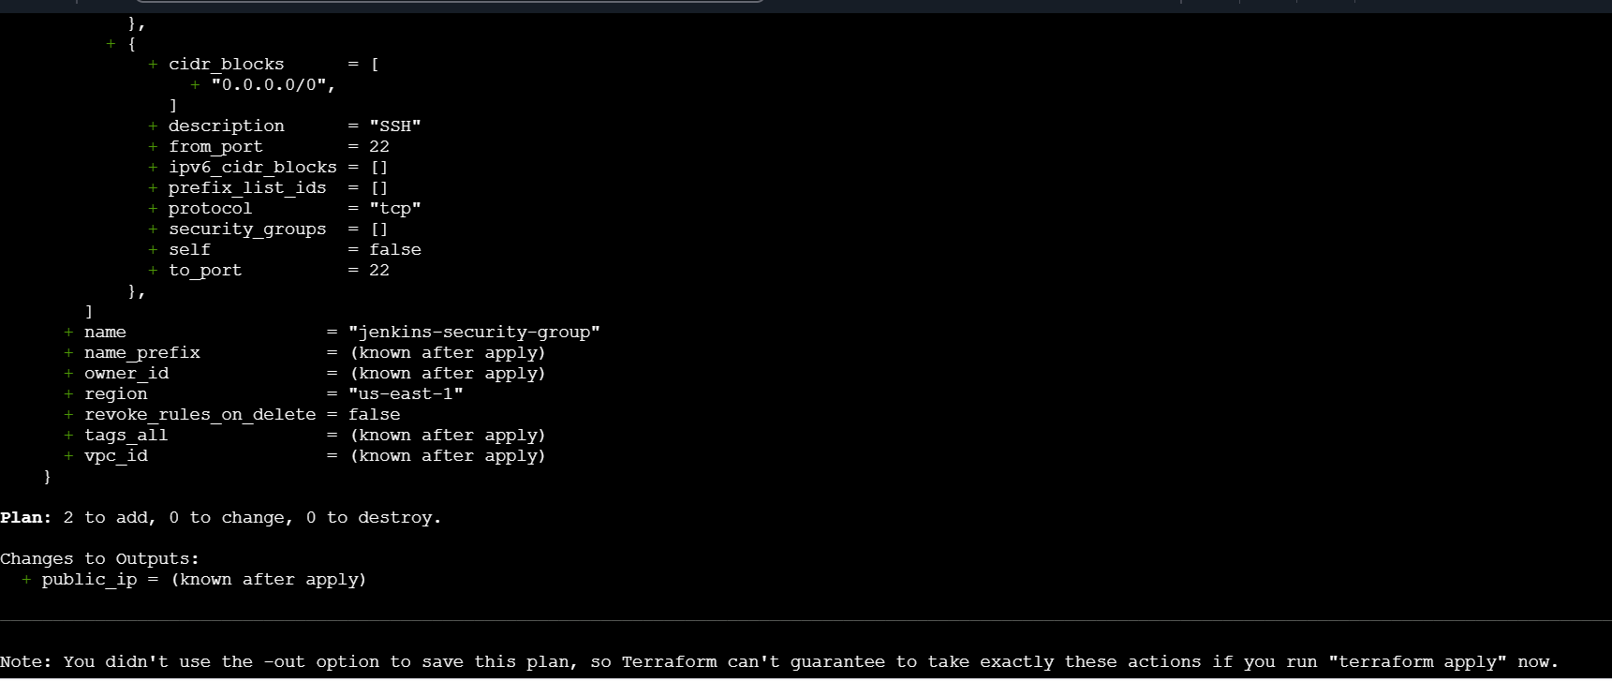
LEts create the Infrastructure now using
terraform apply
It will start create aws instance
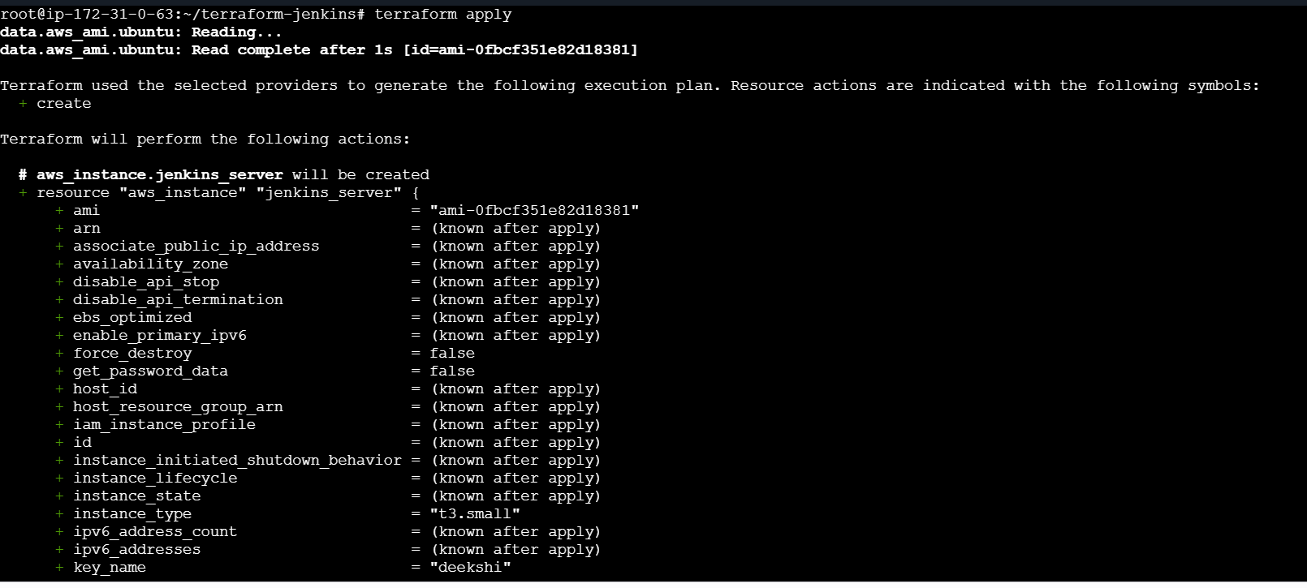
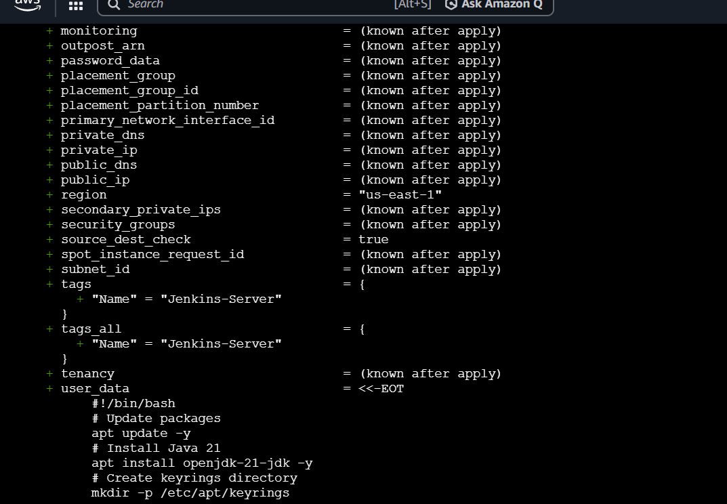
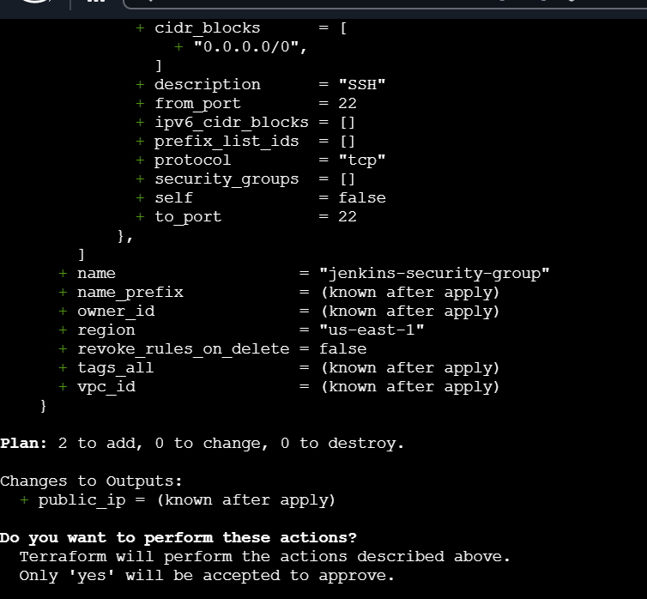
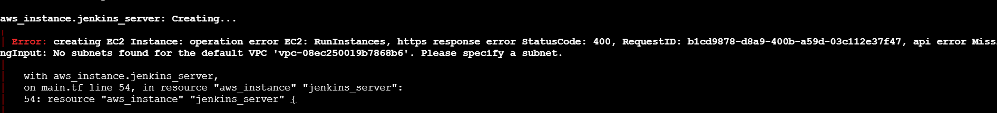
I can go chane to give public ip address and default subnet

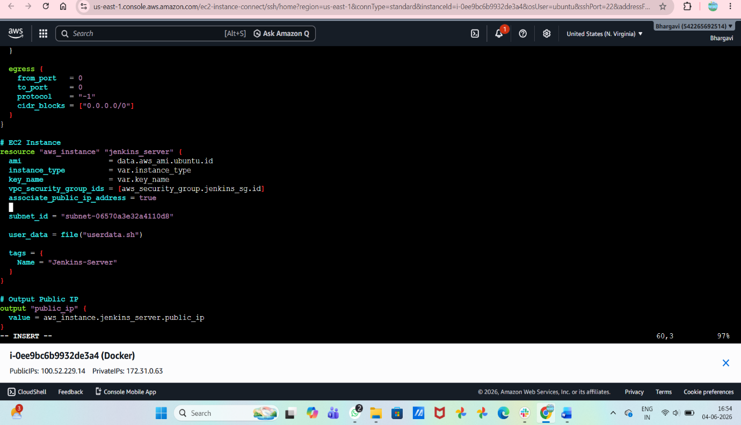
Terraform output

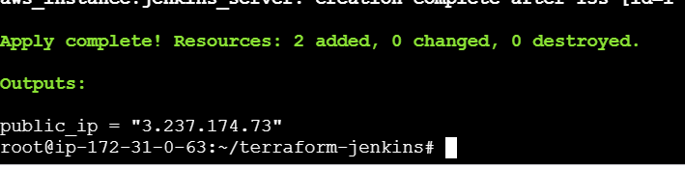
Instanve has been created
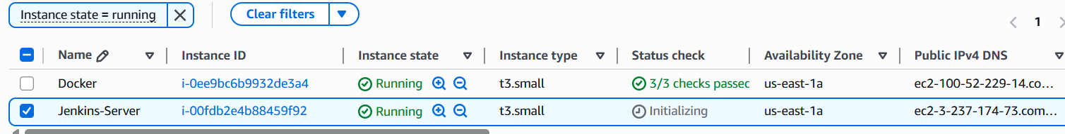
Connect to ec2 instancesysytemctl status jenkins
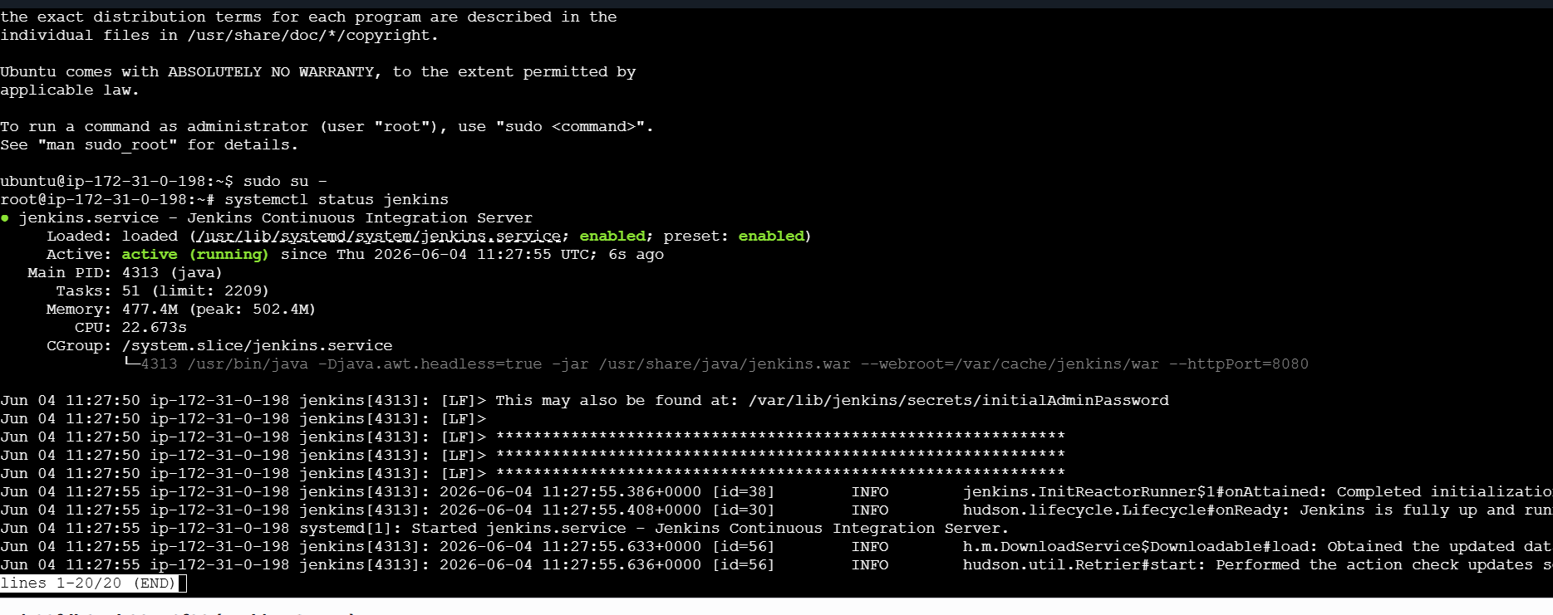
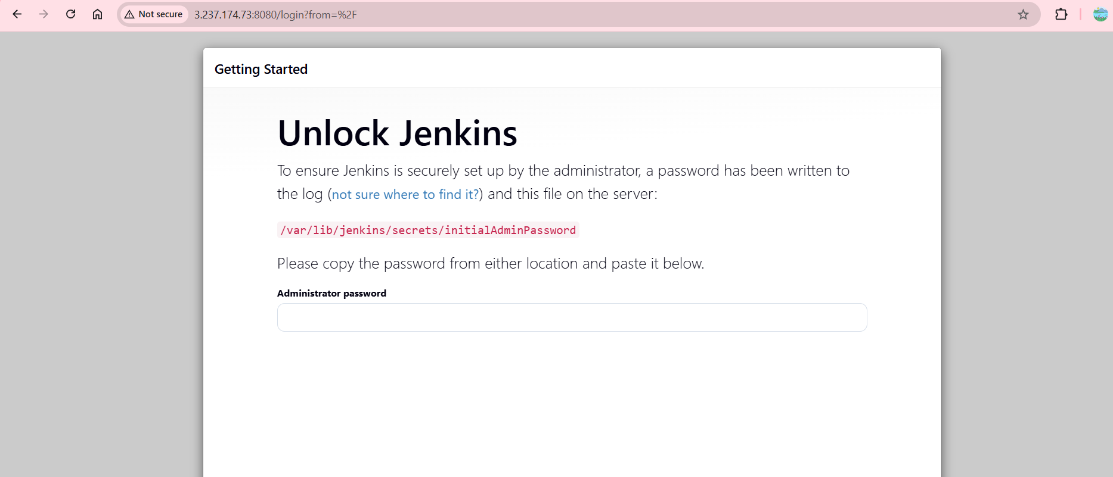
Errors I faced during this task

Subnet id issue
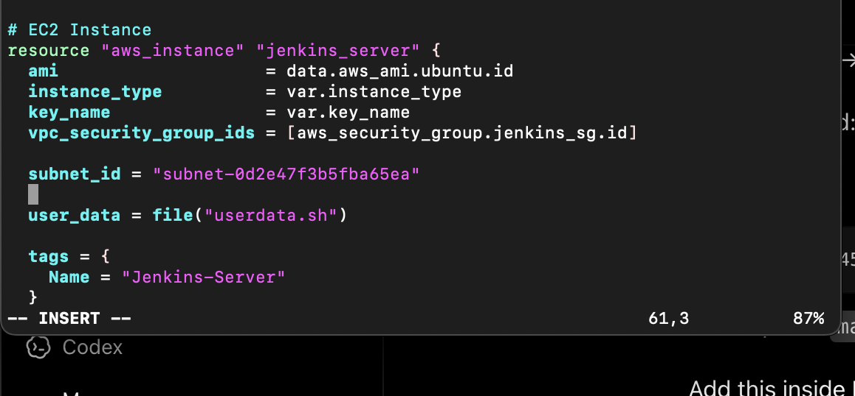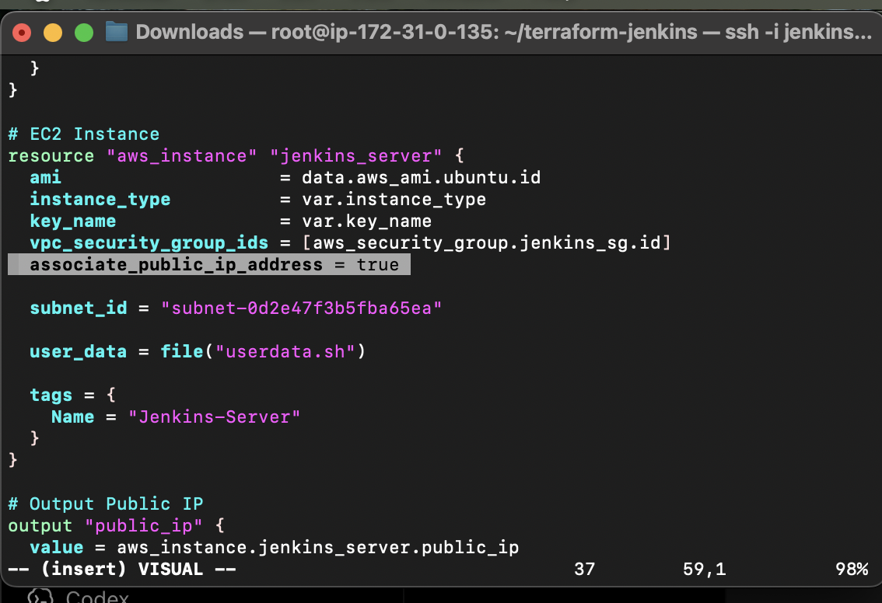
After this has it was completed but no public id was assigned so we will destroy it for that command terraform destroy is used to create all deleted the instancve because we have to create new instance intsrad of this.

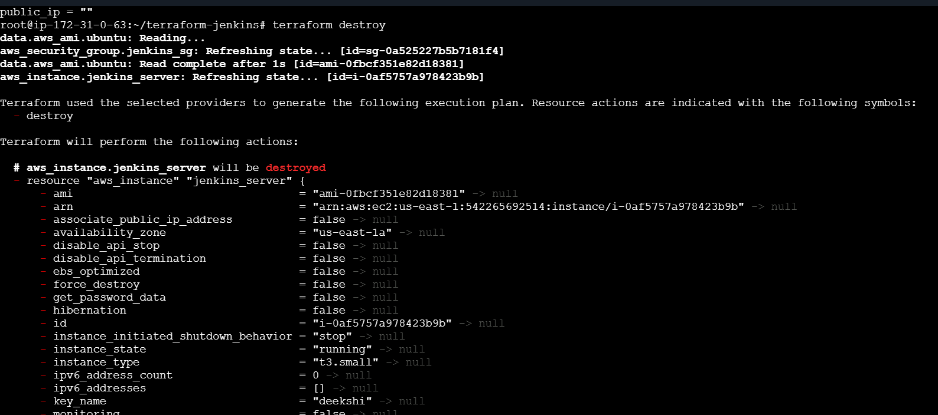
5. Create one Jenkins job to build and push the Docker image to Docker Hub.
docker run -d \
--name jenkins-server \
--restart unless-stopped \
-p 9090:8080 \
-p 50000:50000 \
-v jenkins_home:/var/jenkins_home \
-v /var/run/docker.sock:/var/run/docker.sock \
-u root \
jenkins/jenkins:lts

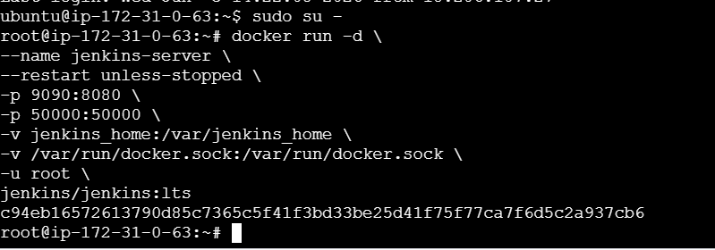
docker start jenkins-server
docker exec -it jenkins-server cat
/var/jenkins_home/secrets/initialAdminPassword
Install both Docker and docker pipeline
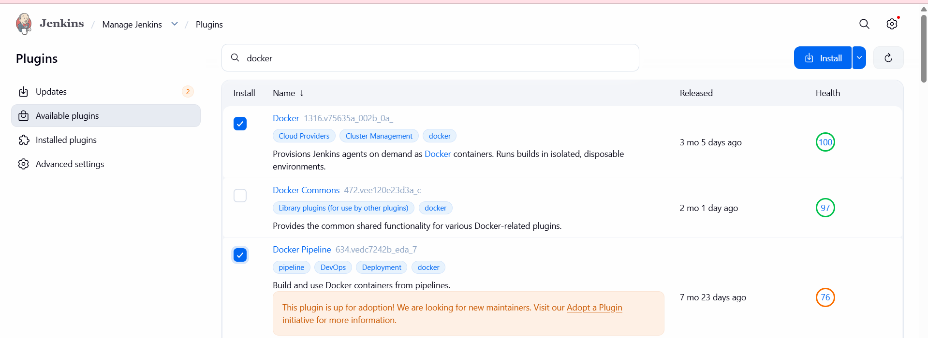
Add Docker Hub Credentials
Manage Jenkins → Credentials → System → Global Credentials → Add
Credentials
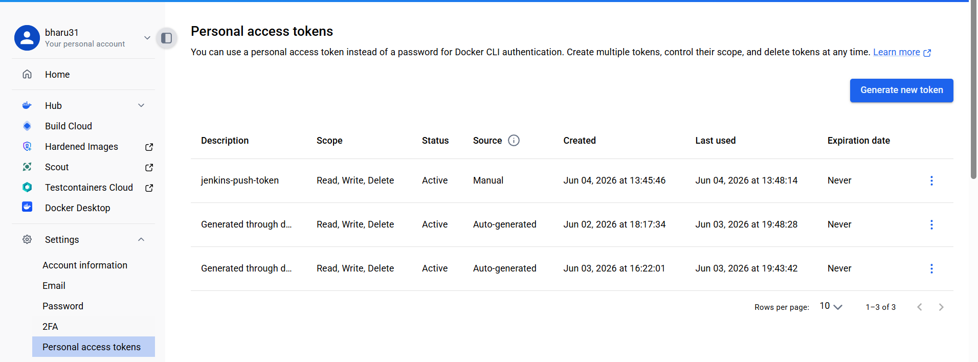
- We have to created in dockerhub personal acces tokens and genearate that token copy that password add that password.
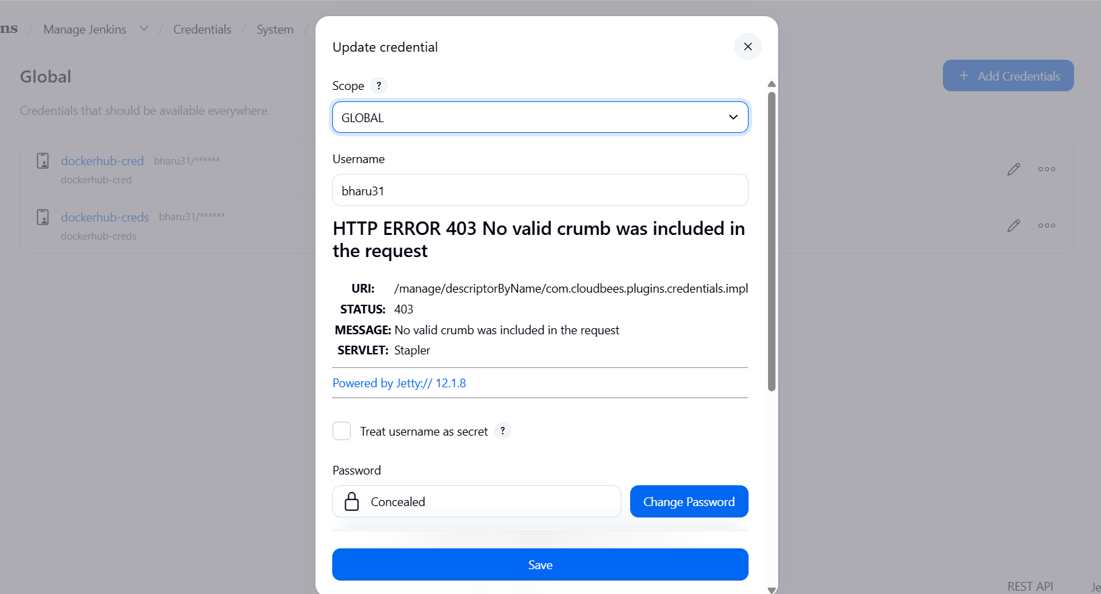
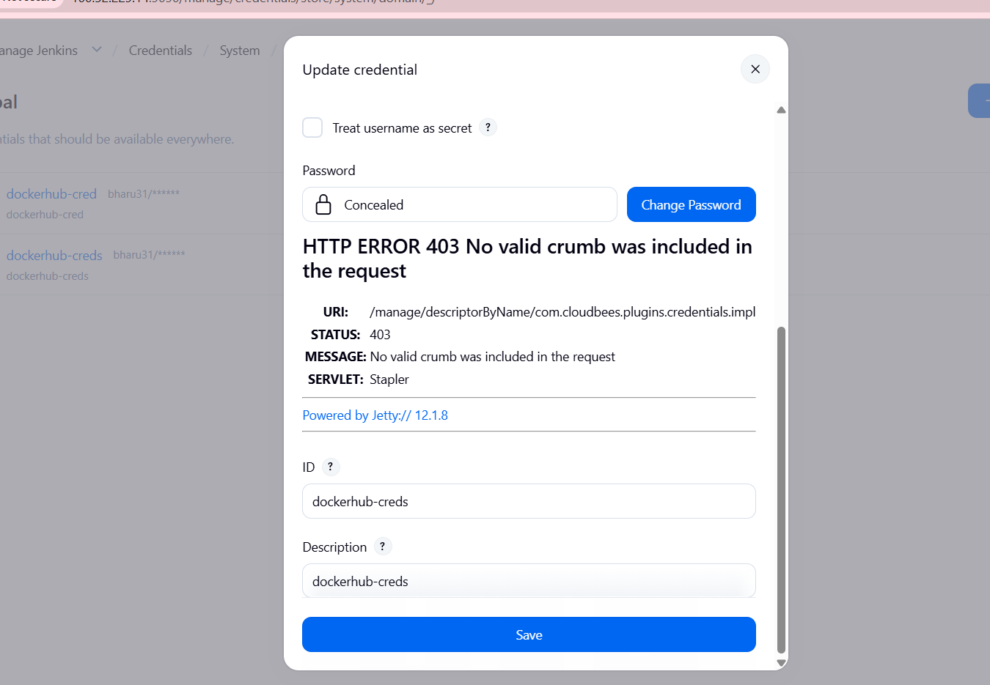
Create Pipeline Job

New Item → Pipeline → Enter Job Name → OK

pipeline {
agent any

environment {
DOCKER_IMAGE = "bharu31/bharu:v3"
}

stages {

stage('Clone Code') {
steps {
git branch: 'master',
url: 'https://github.com/betawins/multi-stage-example.git'
}
}

stage('Create Dockerfile') {
steps {
writeFile file: 'Dockerfile', text: '''
FROM maven:3.8.6-openjdk-8 AS builder
WORKDIR /app
COPY . .
RUN mvn clean package

FROM eclipse-temurin:8-jre
WORKDIR /app
COPY --from=builder /app/target/*.jar app.jar
EXPOSE 8080
ENTRYPOINT ["java","-jar","app.jar"]
'''
}
}

stage('Build Docker Image') {
steps {
sh "docker build -t ${DOCKER_IMAGE} ."
}
}

stage('Docker Hub Login') {
steps {
withCredentials([usernamePassword(
credentialsId: 'dockerhub-creds',
usernameVariable: 'DOCKER_USER',
passwordVariable: 'DOCKER_PASS'
)]) {
sh 'echo $DOCKER_PASS | docker login -u $DOCKER_USER --password-stdin'
}
}
}

stage('Push Docker Image') {
steps {
sh "docker push ${DOCKER_IMAGE}"
}
}
}
}
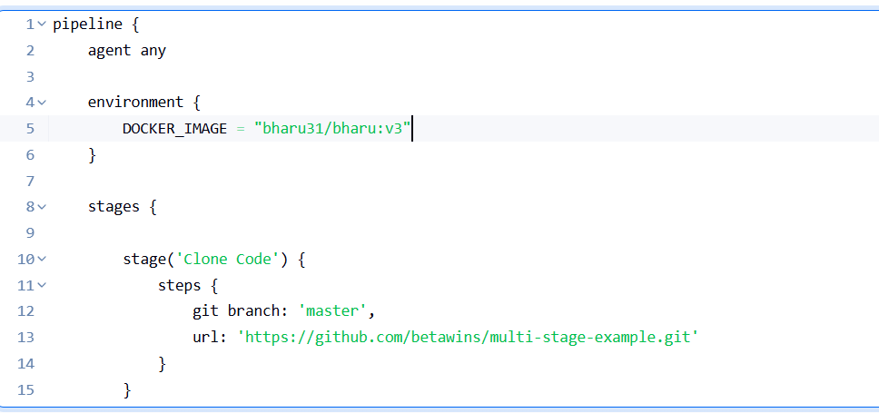
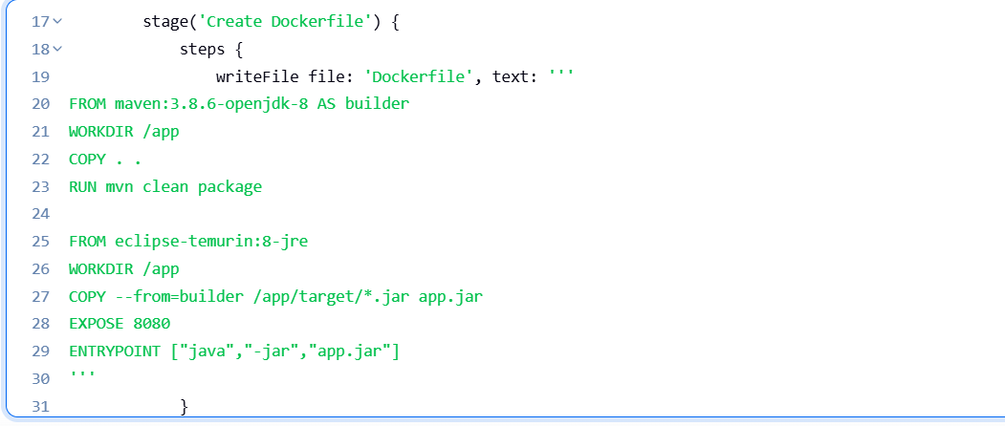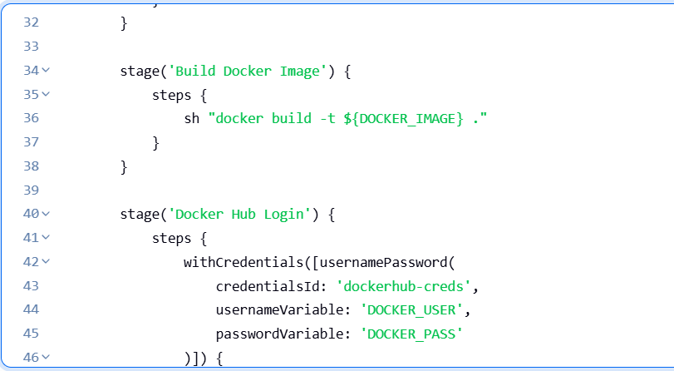
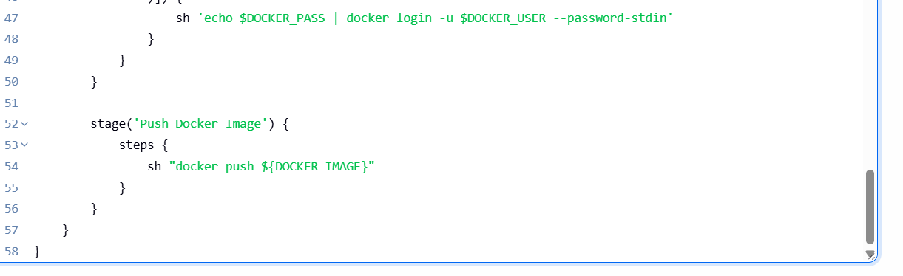
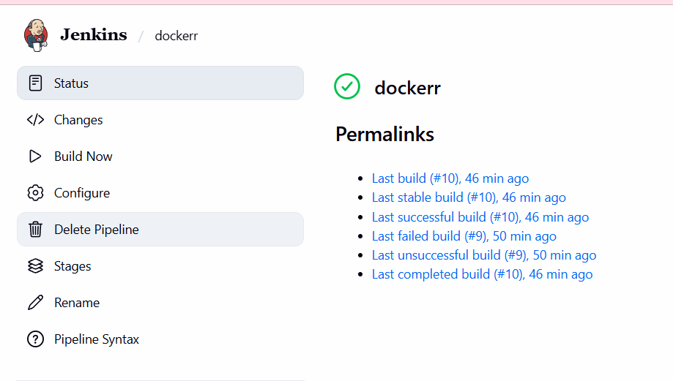

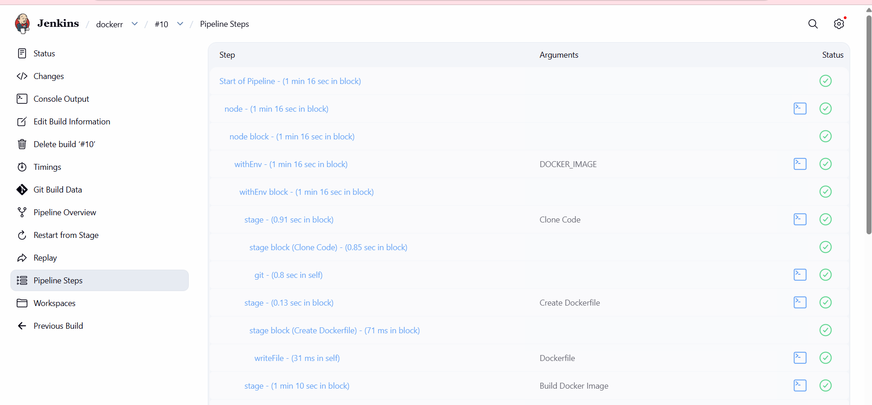
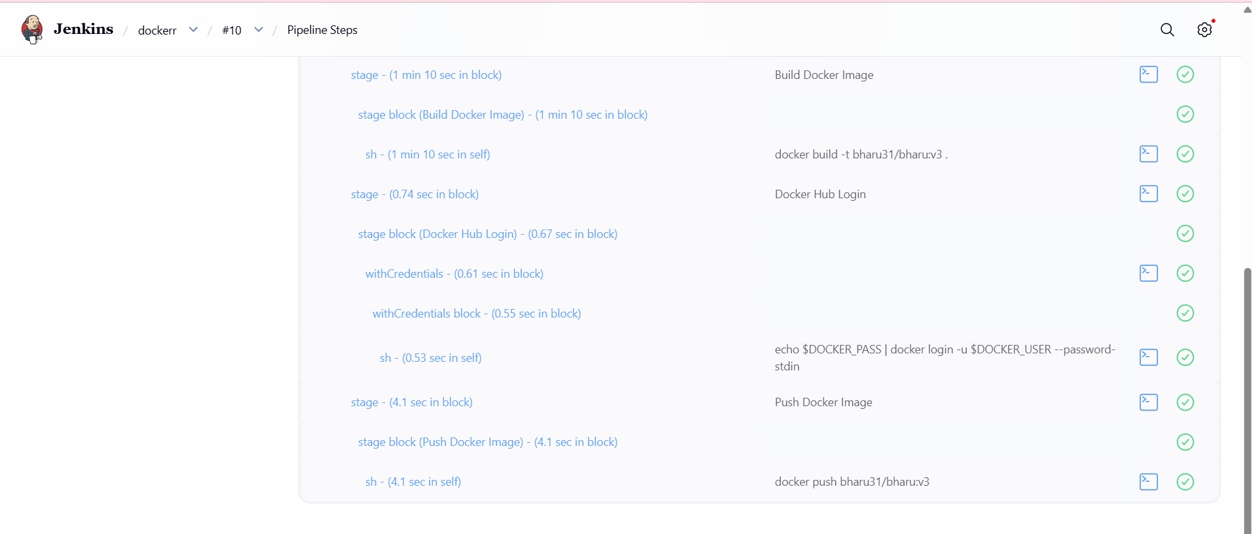
The image was pulled successfully
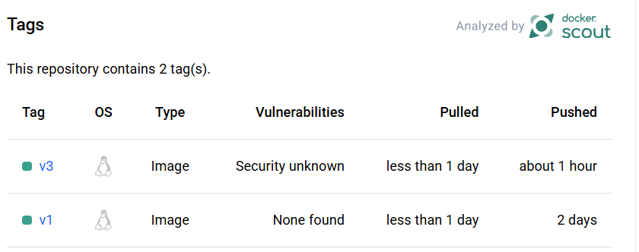

6. Source Codes: https://github.com/betawins/docker-tasks.git
- From thefrontend source code, write a Dockerfile, build a Docker image, run it, and push that image to your Docker registry.

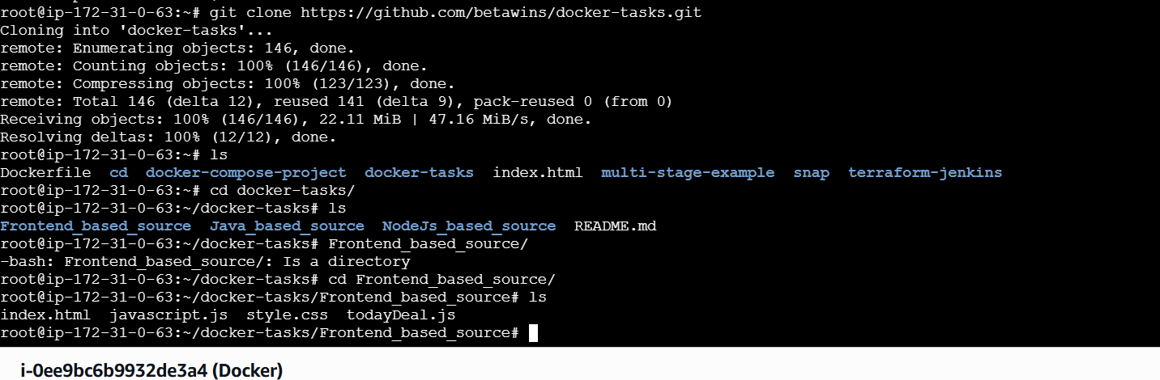
Now lets create a vi Dockerfile
FROM nginx:alpine

COPY . /usr/share/nginx/html

EXPOSE 80

CMD ["nginx", "-g", "daemon off;"]

Why this Dockerfile?
- FROM node:18-alpine → lightweight Node.js image
- WORKDIR /app → creates working directory inside container
- COPY package*.json ./ → copies dependency files first for caching
- RUN npm install → installs required packages
- COPY . . → copies source code
- EXPOSE 3000 → exposes frontend app port
- CMD ["npm", "start"] → starts frontend app

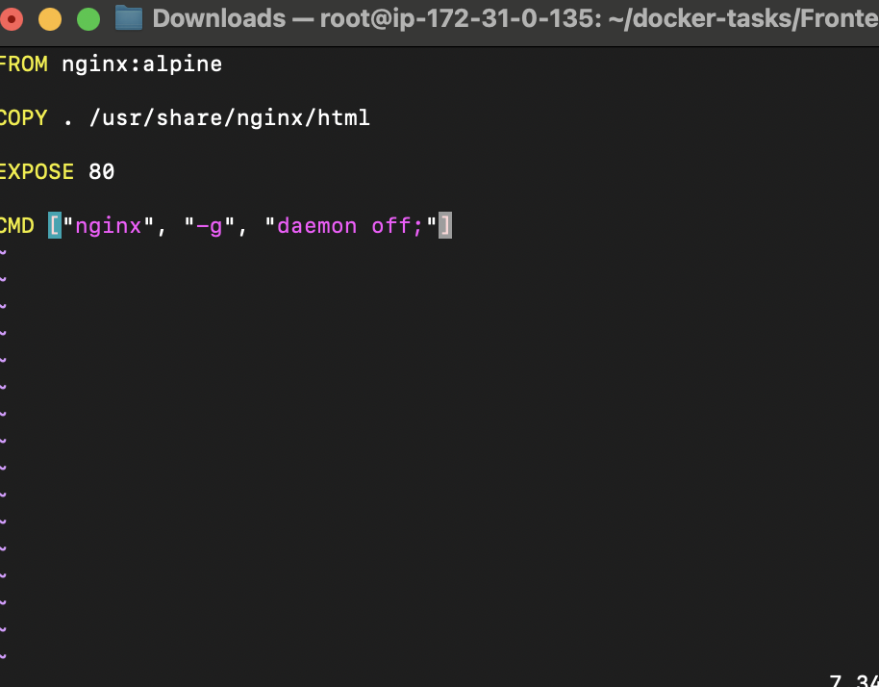
This docker file downloads the latest nginx image and copies all the files from current
directory to /usr/share/nginx/html
Lets now build the image using command
docker build -t frontend-app:v1 .
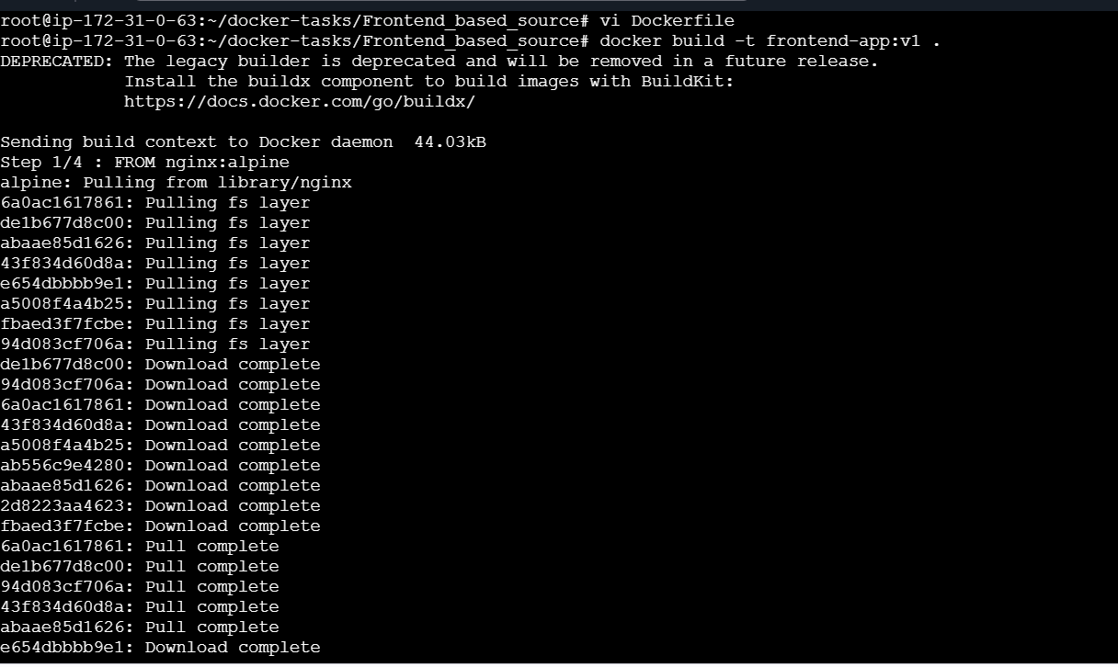
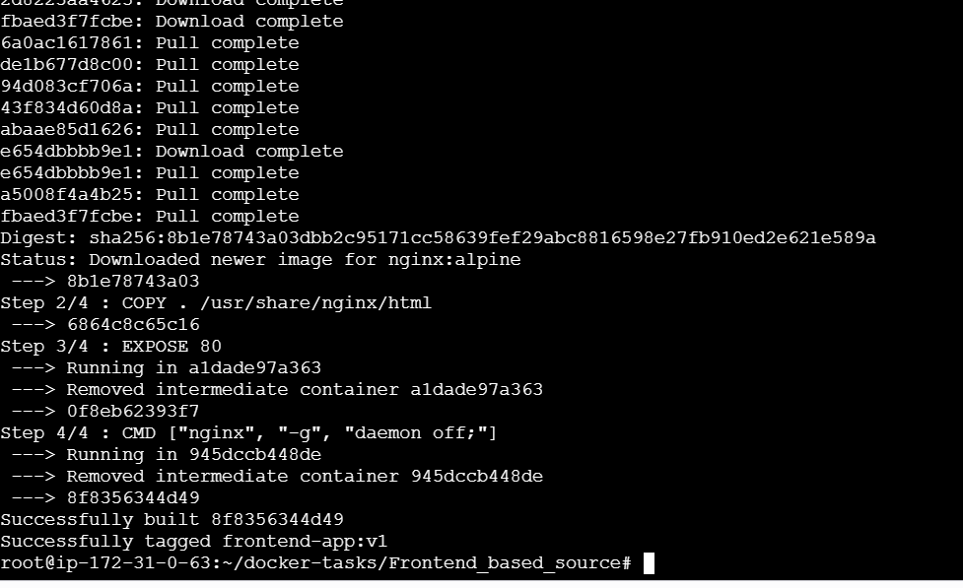
Docker images
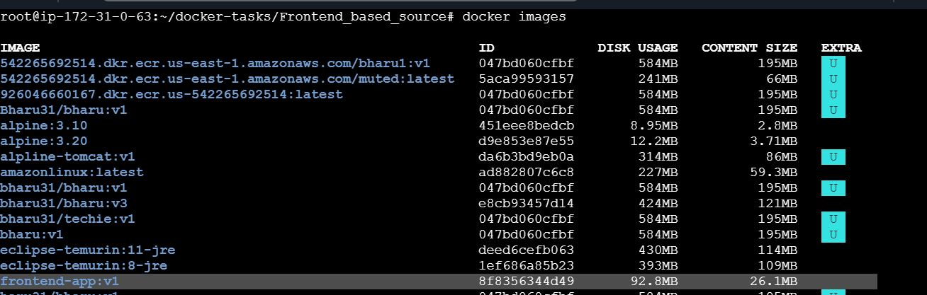
docker run -d --name frontend-container -p 8087:80 frontend-app:v1
And Docker ps
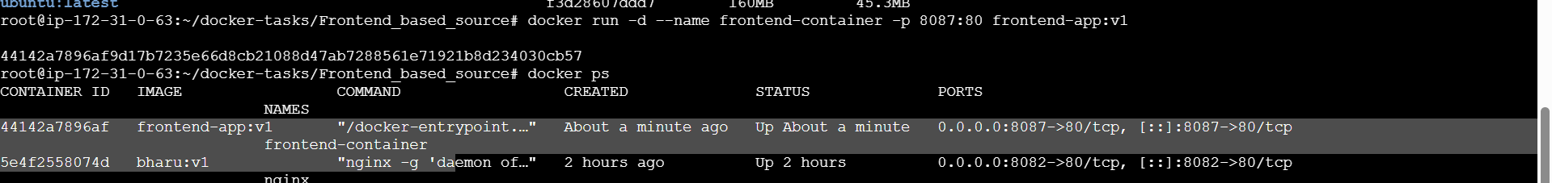
Lets check if its Access in Browser

Lets push it to docker hub
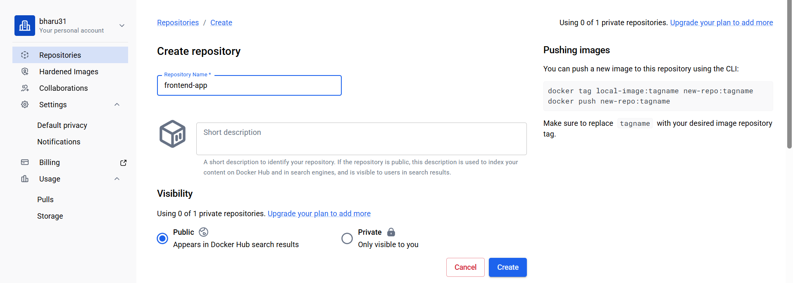
docker tag frontend-app:v1 bharu31/frontend-app:v1
docker login
docker push javeebms7/frontend-app:v1
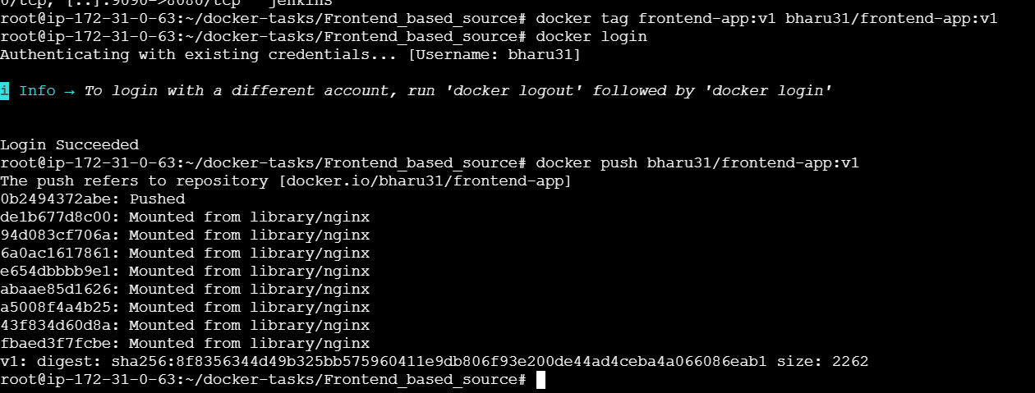
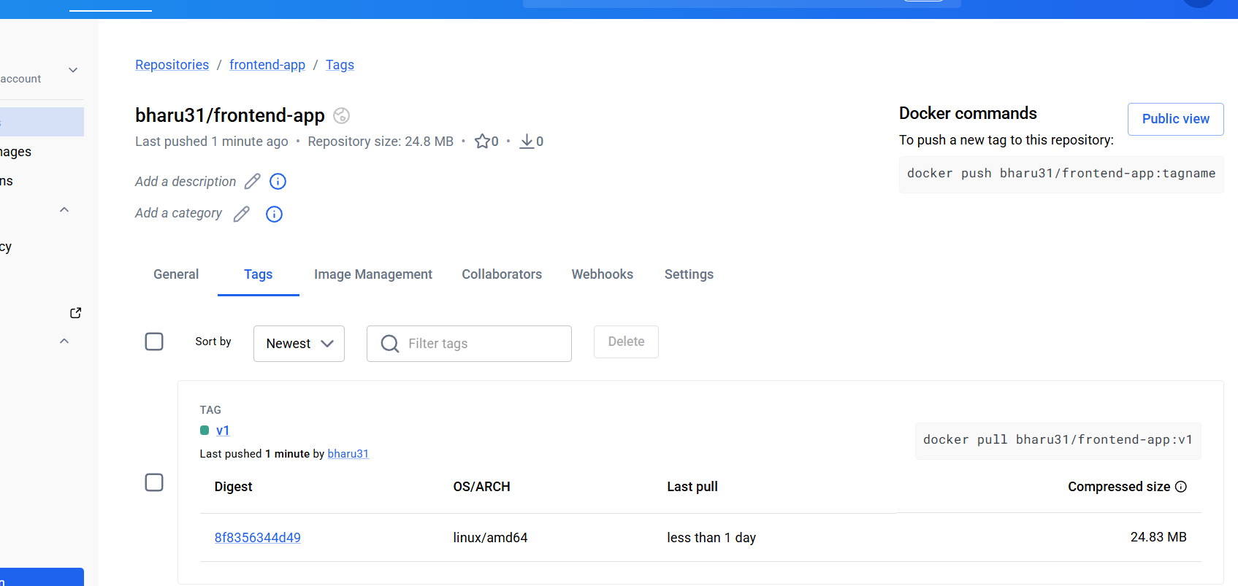
7. From theJava-based source code, write a Dockerfile, build, run, and push the image to the Docker registry.
Now let’s do the Java-based source code properly.
First go into the Java project:
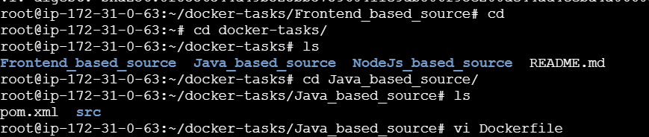

# Use Maven to build application
FROM maven:3.9.6-eclipse-temurin-17 AS build

WORKDIR /app

COPY . .

RUN mvn clean package -DskipTests

# Runtime image
FROM eclipse-temurin:17-jdk-alpine

WORKDIR /app

COPY --from=build /app/target/*.jar app.jar

EXPOSE 8080

CMD ["java", "-jar", "app.jar"]
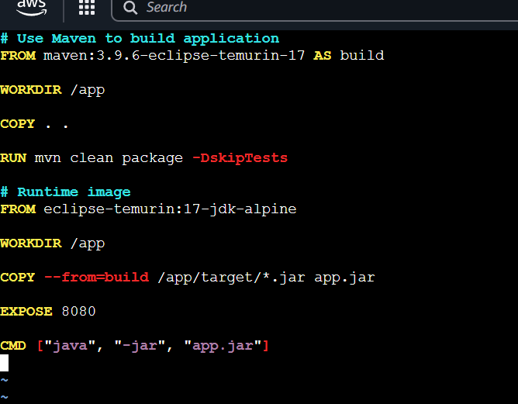
This Dockerfile is a multi-stage Dockerfile used to build and run the Java application efficiently. In the first stage, it uses a Docker image with Maven and Java to build the project and generate the JAR file. It creates a working directory called /app and copies all project files into the container. After building the application, the second stage uses a smaller Java runtime image to reduce image size. It copies only the generated JAR file from the build stage and exposes port 8080 to access the application. Finally, it starts the application using the command java -jar app.jar. This approach makes the Docker image smaller, cleaner, and efficient.
Lets build the image using command
docker build -t java-app:v1 .
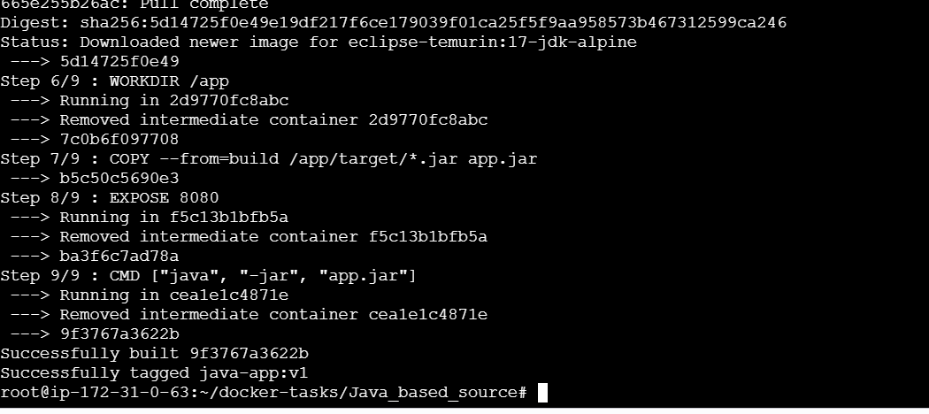
docker run -d --name java-container -p 8086:8080 java-app:v1
docker images
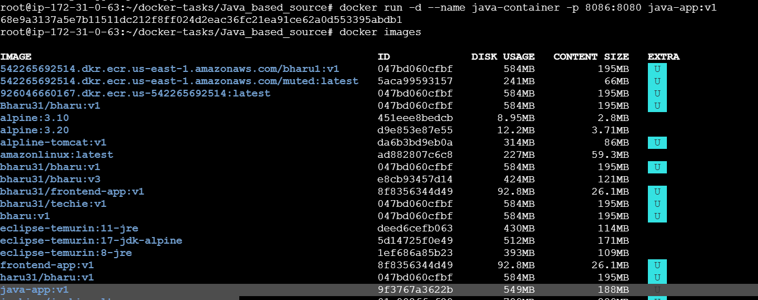
Lets check in browser
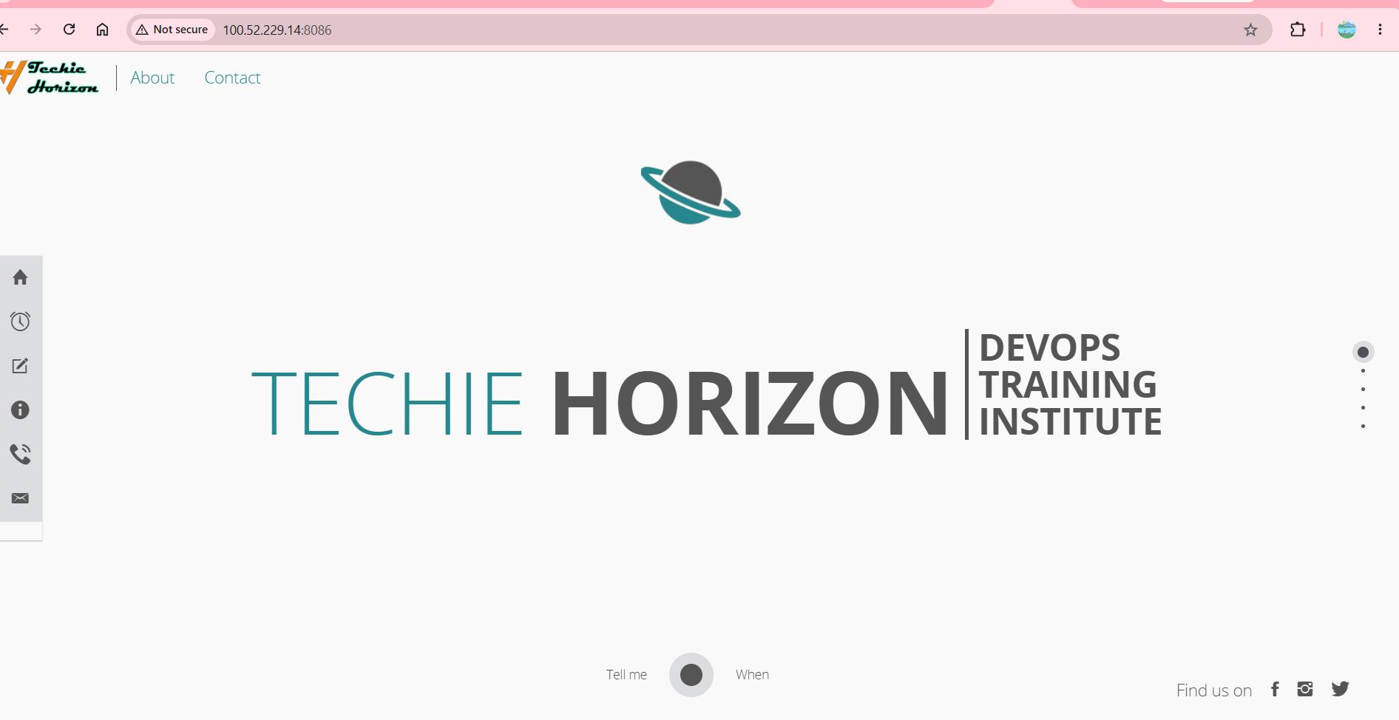
Lets push to DockerHub
Create a new repo
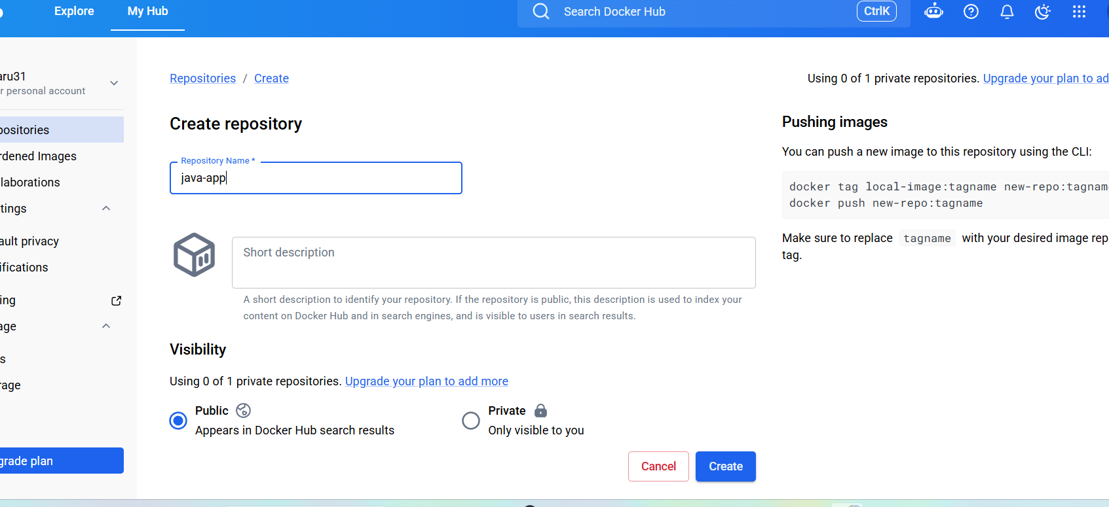
docker tag java-app:v1 bharu31/java-app:v1
Docker push bharu31/java-app:v1
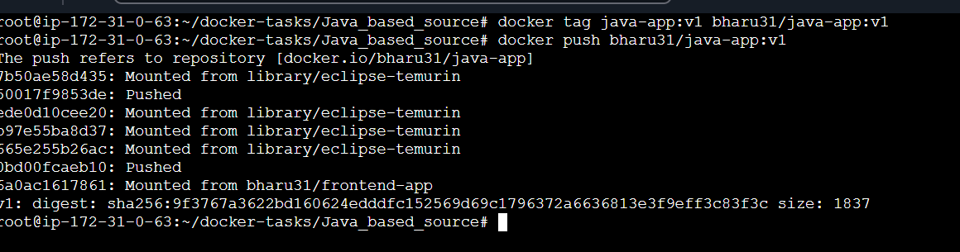
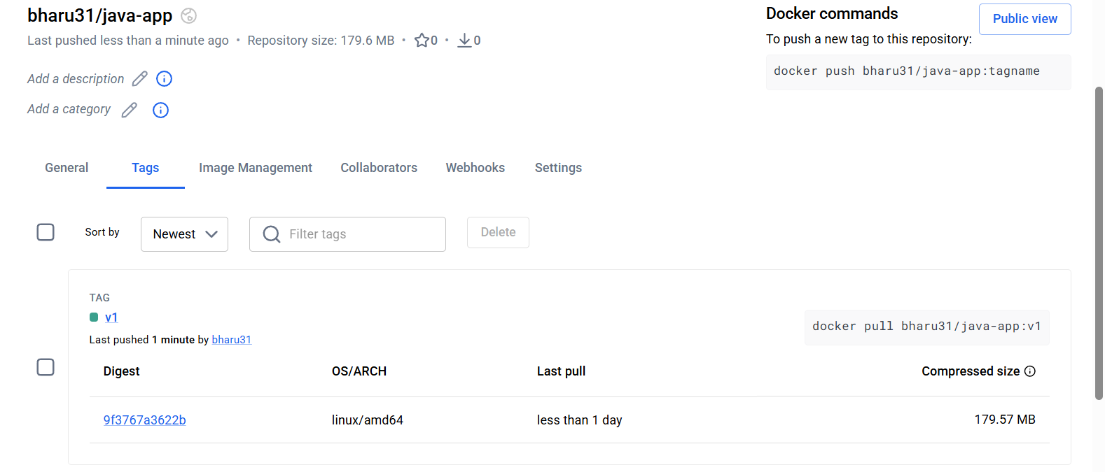
8. From theNode.js-based source code, write a Dockerfile, build with tagv1, run, and push it to the Docker registry.
Now let’s do the Node.js-based source code properly.
First go into the node.js project:
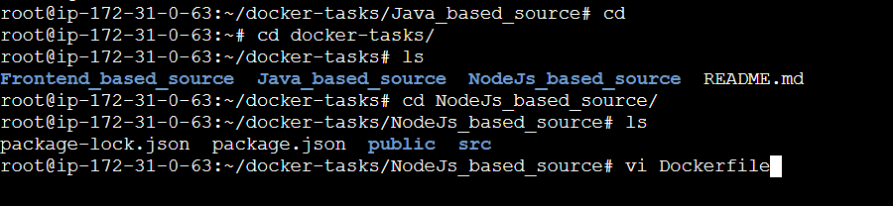
Create a vi Dockerfile
FROM node:18-alpine

WORKDIR /app

COPY package*.json ./

RUN npm install

COPY . .

EXPOSE 3000

CMD ["npm", "start"]
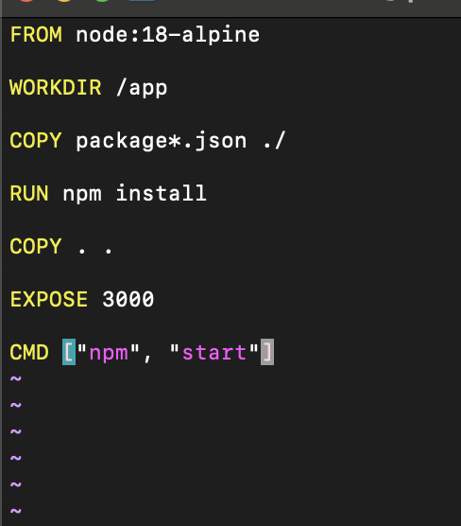

This Dockerfile uses a Node.js image to run the application. First, it creates a working directory called /app inside the container. Then it copies the package.json files and installs all required dependencies using npm install. After installing dependencies, it copies the remaining application files into the container. It exposes port 3000 so the application can be accessed from outside the container. Finally, it starts the Node.js application using the npm start command.

Build Docker Image with tag v1
docker build -t node-app:v1 .
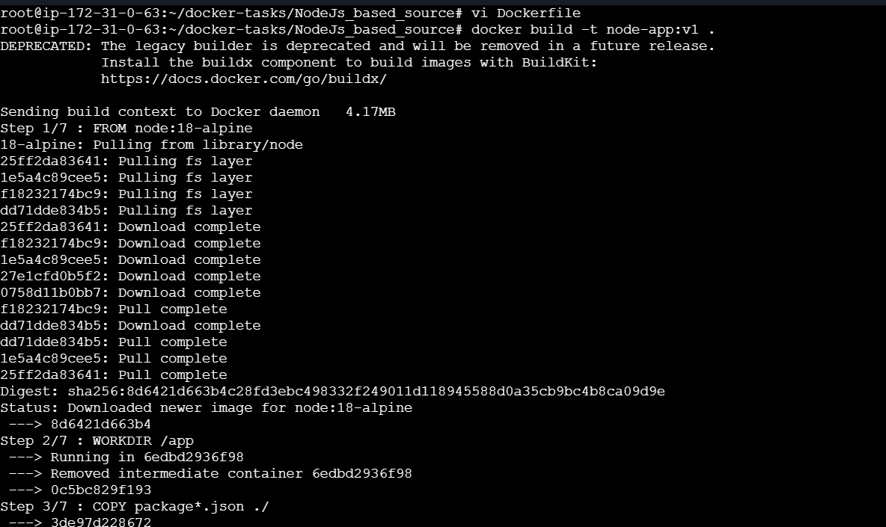

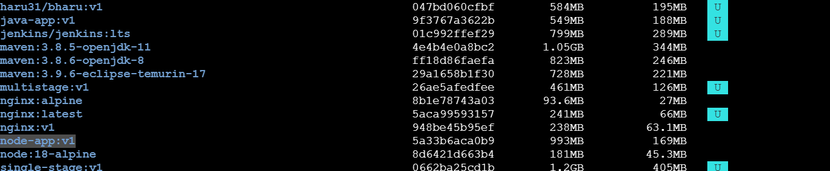
Run the container

docker run -d --name node-container -p 3001:3000 node-app:v1
Docker ps

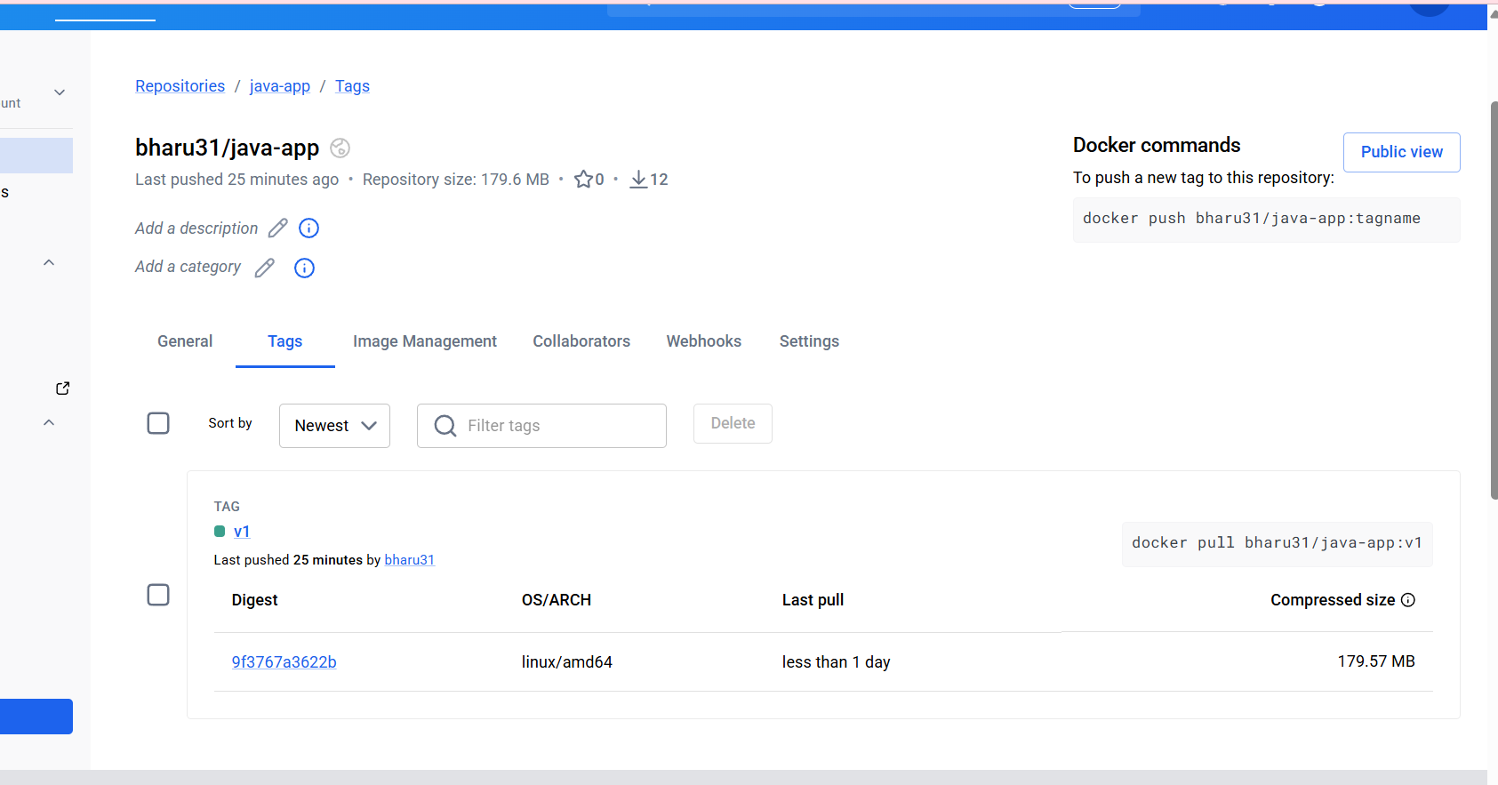
9. Write a docker-compose file to set up WordPress with a MySQL database.
Create a docker-compose.yml file using command vi
version: '3'

services:
db:
image: mysql:5.7
volumes:
- db_data:/var/lib/mysql
restart: always
environment:
MYSQL_ROOT_PASSWORD: somewordpress
MYSQL_DATABASE: wordpress
MYSQL_USER: wordpress
MYSQL_PASSWORD: wordpress

wordpress:
depends_on:
- db
image: wordpress:latest
ports:
- "8000:80"
restart: always
environment:
WORDPRESS_DB_HOST: db:3306
WORDPRESS_DB_USER: wordpress
WORDPRESS_DB_PASSWORD: wordpress
WORDPRESS_DB_NAME: wordpress

volumes:
db_data:
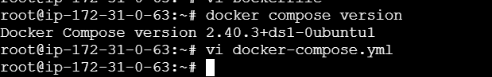
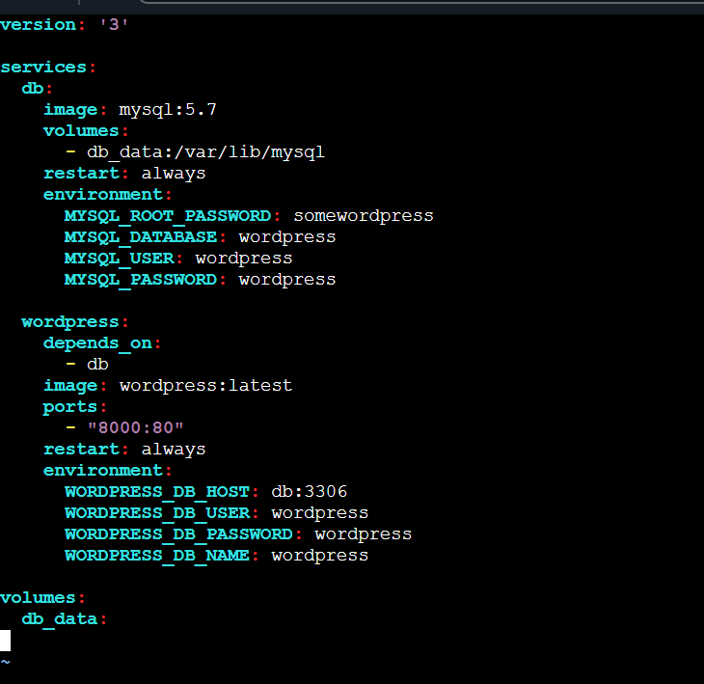
Lets start these services, save the file and run using command
docker-compose up
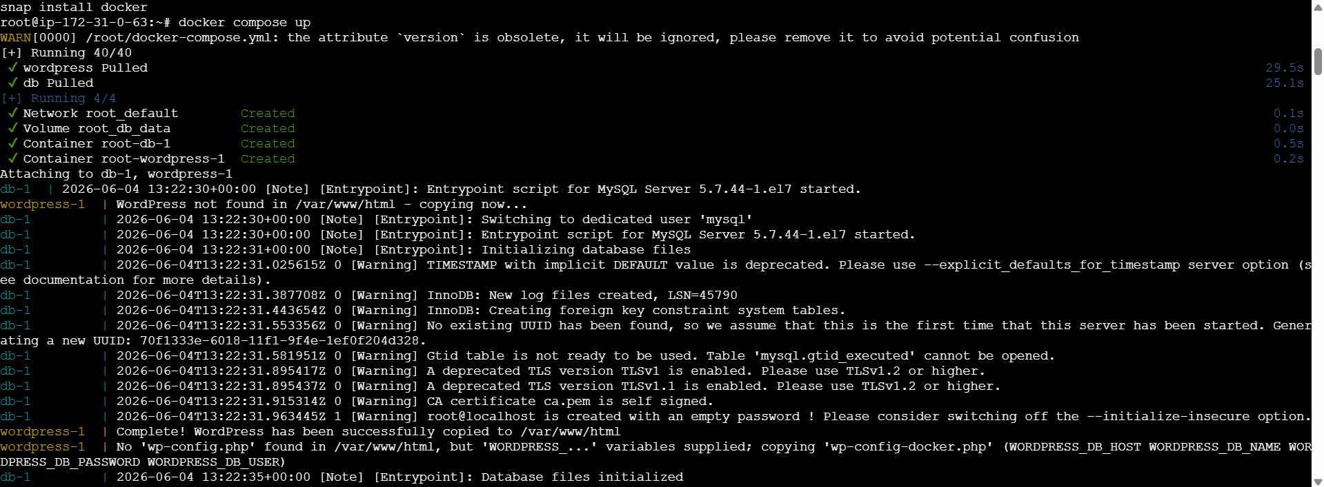
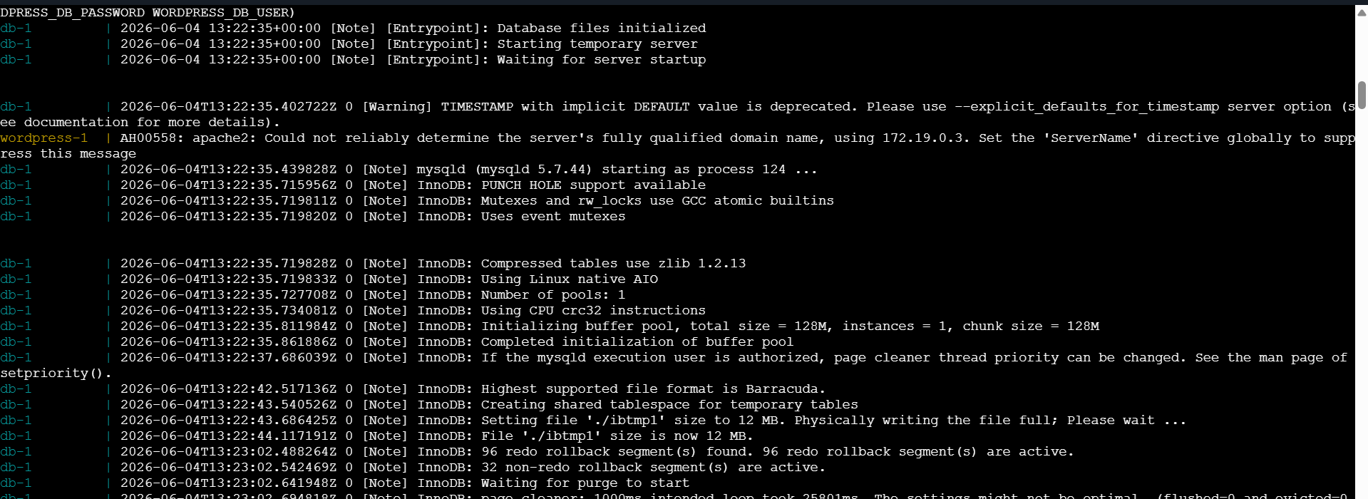
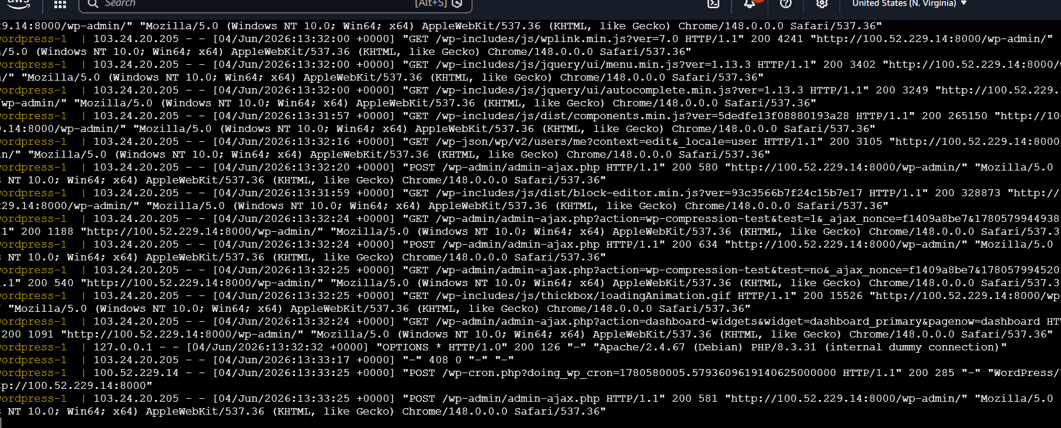
Now if we check in another CLI and do
docker ps
We can see wordpress and mysql are running
By doing docker-compose ps we can see list of containers running in docker-compose
